

CAPSTONE PROJECT REPORT
Report 3 – Software Requirement Specification

– DaNang, October 2026 –
Table of Contents
I. Record of Changes 6
II. Software Requirement Specification 7
1. Product Overview 7
2. User Requirements 7
2.1. Actors 7
2.2. Use Cases 8
2.2.1. Diagram(s) 8
2.2.2. Descriptions 11
3. Functional Requirements 13
3.1. System Functional Overview 13
3.1.1. Screens Flow 13
3.1.2. Screen Descriptions 14
3.1.3. Screen Authorization 15
3.1.5 Entity Relationship Diagram 16
3.2. Authentication 18
3.2.1. Login/logout 18
Function trigger:
The user navigates to the Login page and submits their email and password, or chooses to continue with Google. 18
3.2.2. Register Account 19
3.2.3. Forgot/Change Password 19
3.3. User Management 20
3.3.1. CRUD User 20
3.3.2. Profile Management 21
3.3.4. Shopping Cart and Payment 23
3.4. Host Management 24
3.4.1. Approve Host Registration 24
3.4.2. Reject Host Registration 25
3.4.3. Product Upload By Host 26
3.4.4. Order Management By Host 27
3.4.5. Assigning Tour Guides 28
3.4.6. Factory Owner Overview 29
3.5. Revenue Management 30
3.5.1. View Total Revenue 30
3.5.2. Generate Sales Report 31
3.5.3. Export Revenue Report 32
3.5.4. Statistics Management 32
3.6. Ticket Management 33
3.6.1. Ticket Booking and Payment 33
3.7. Workshop Management 34
3.7.1. CRUD Workshop 34
3.7.2. Workshop/Product Search 35
3.7.3. Workshop/Product Information 36
3.7.4. Create Time Slots 37
3.8. Review Management 38
3.8.1. Review Workshop 38
3.8.2. Review Product 38
3.9. AI Chatbot 38
3.10. Notification Management 40
3.10.1. Send Order Notification 40
3.10.2. User’s Notification 41
4. Non-Functional Requirements 41
4.1. External Interfaces 41
4.1.1. Database Interfaces 41
4.1.2. API Interfaces 42
4.1.3. Frontend Interfaces 42
4.1.4. External Service Interfaces 43
4.2 Quality Attributes 44
4.2.1. Usability 44
4.2.2. Reliability 44
4.2.3. Performance 44
5. Requirement Appendix 45
5.2. Common Requirement 47
5.3. Application Messages List 48
5.4. Other Requirements… 50

I. Record of Changes
Date | A*  M, D | In charge | Change Description
13/10/2026 | A | ThuanXD | Create the software requirement specification
15/10/2026 | A | NganVM, ThuanXD | Add the system’s entity relationship diagram
15/10/2026 | A | NhatTD | Add the system’s context diagram
16/10/2026 | A | ThuanXD | Add the system’s requirement appendix
16/10/2026 | A | TaiVD | Add the system’s overview use case diagram
17/10/2026 | M | NhiLB | Update UC and EDRD
17/10/2026 | M | NganVM, NhatTD,  NhiLB,  ThuanXD | Update screen flow, update description and design
*A - Added M - Modified D - Deleted

II. Software Requirement Specification

1. Product Overview
The CraftWS System is a platform that connects tourists with local workshop hosts, artisans, and tour guides. It allows tourists to discover cultural workshops, view available schedules, book time slots, make online payments, receive QR e-tickets, and purchase local handmade products. Hosts can manage workshops, time slots, products, customer orders, and tour guides, while tour guides can view assigned schedules, check in customers using QR tickets, and update workshop progress. Administrators are responsible for managing users, approving Host accounts, and monitoring the overall operation and revenue of the platform. By combining workshop booking and local product shopping in one system, CraftLocal helps tourists access local cultural experiences more conveniently while giving local providers a structured way to manage their services and products.
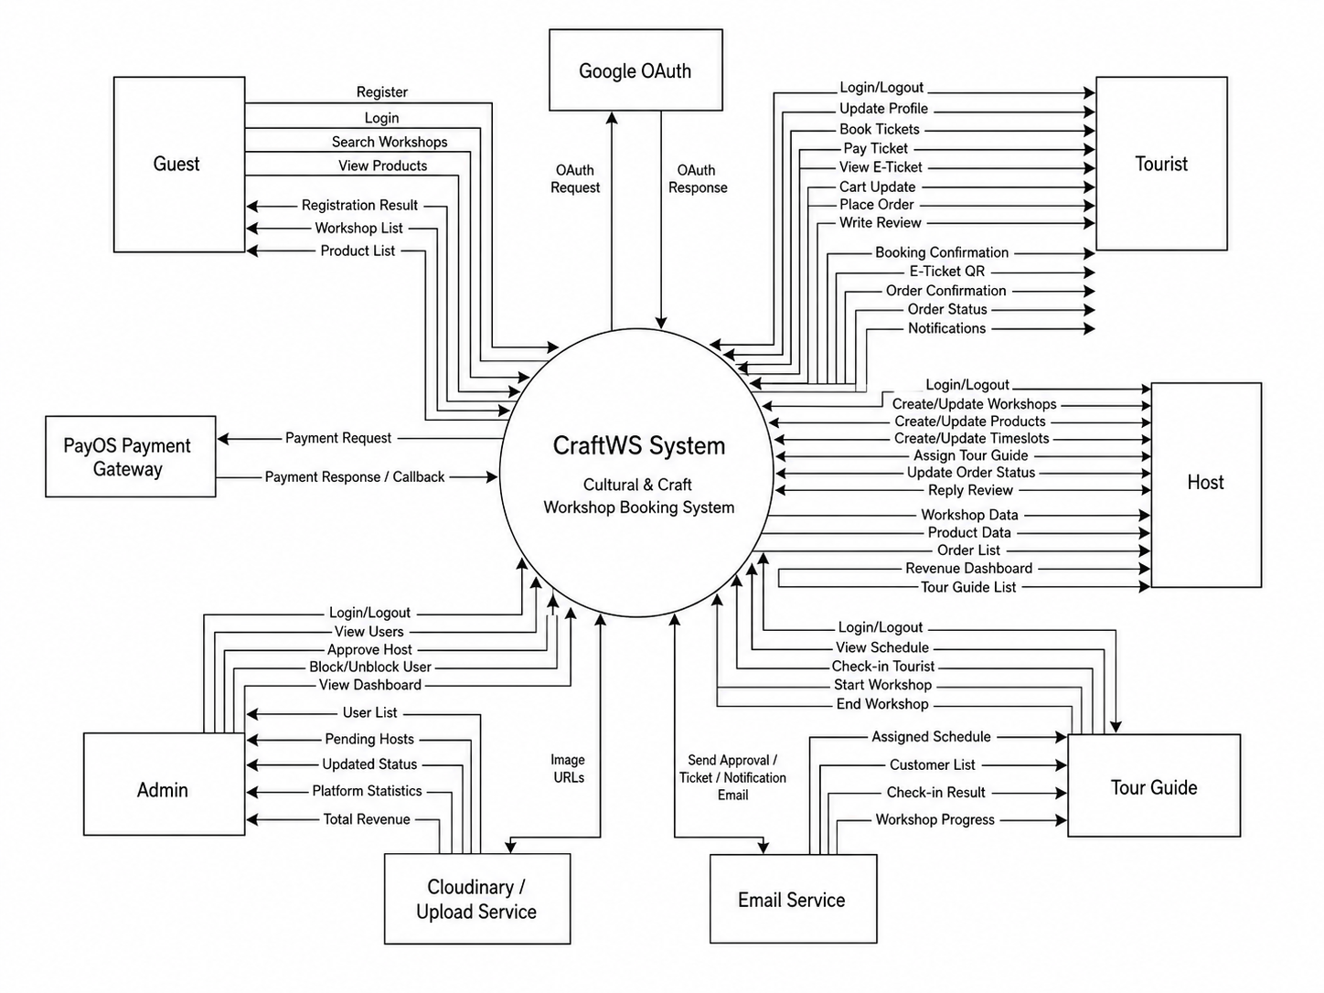

2. User Requirements

2.1. Actors
# | Actor | Description
1 | Tourist | Tourists are the main customer of the system. They can browse workshops and local products, view workshop schedules, book available time slots, make online payments, receive QR e-tickets, and check their booking and order history. After completing a workshop or product order, tourists can also submit reviews and ratings.
2 | Host | Host is a local workshop provider or artisan who manages the services and products offered on the platform. Hosts can create and update workshops, manage time slots and available capacity, manage products and customer orders, create Tour Guide accounts, assign guides to workshop schedules, and view their business dashboard and revenue information.
3 | Tour Guide | Tour Guide is responsible for operating workshop sessions assigned by a Host. They can view their assigned schedules, check the customer list for each session, scan QR tickets to check in customers, and update the workshop progress from start to completion.
4 | Admin | Admin manages and monitors the overall CraftLocal platform. They can manage user accounts, review and approve Host registrations, block or unblock users when necessary, and monitor platform statistics, transactions, and revenue information.

2.2. Use Cases

2.2.1. Diagram(s)

2.2.1.1: Overall Use-Case
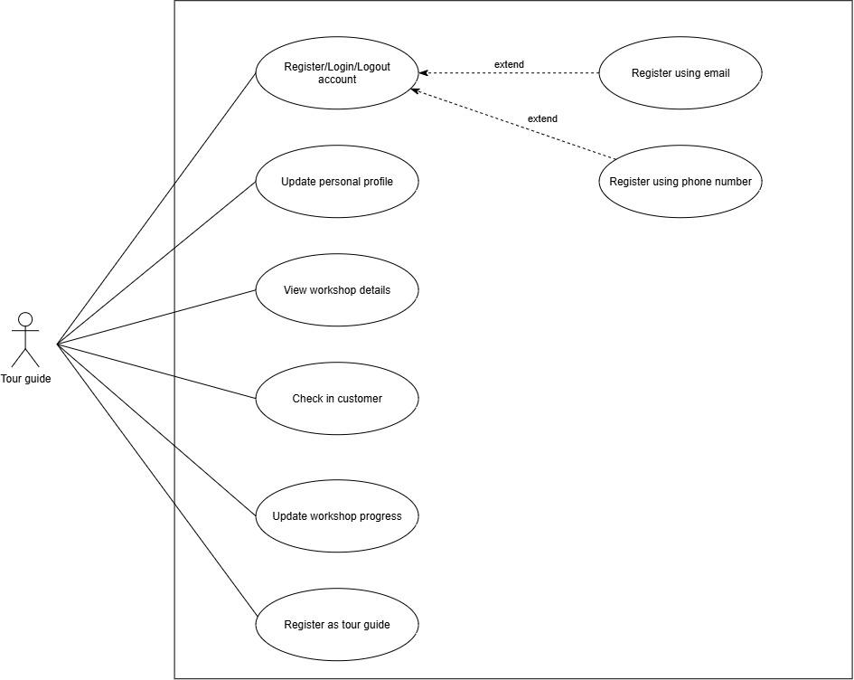
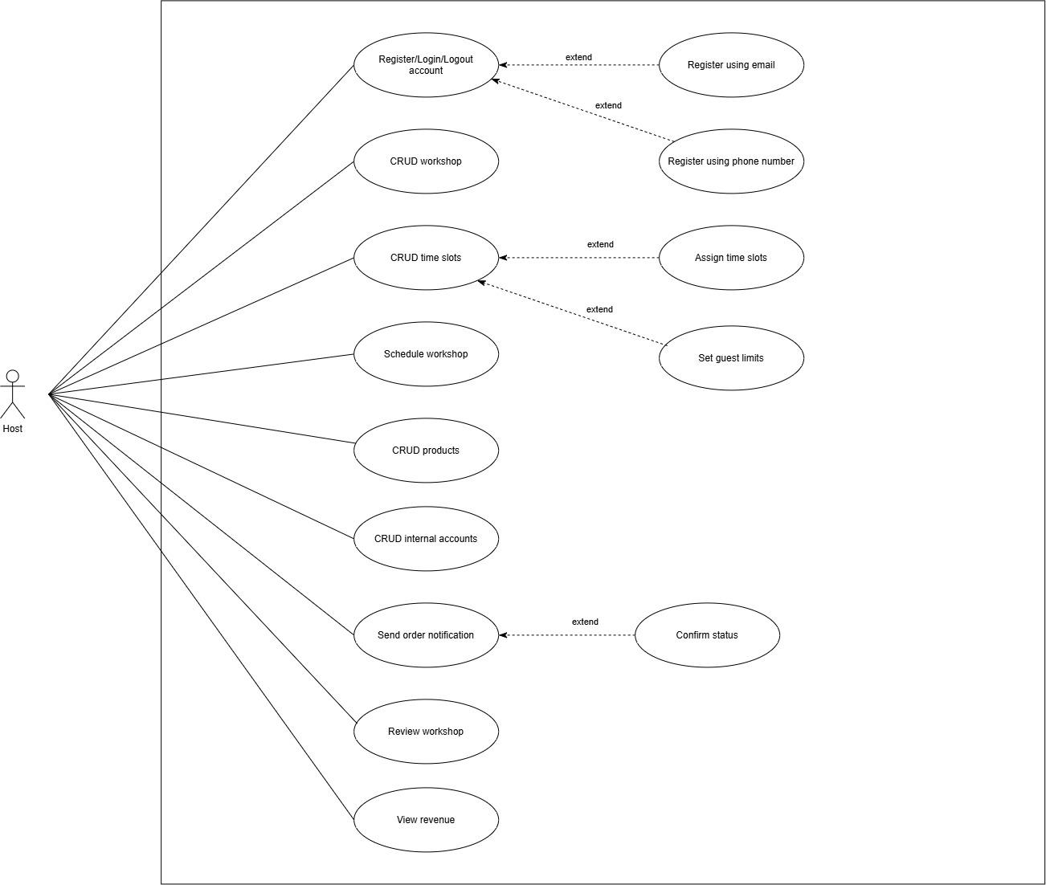
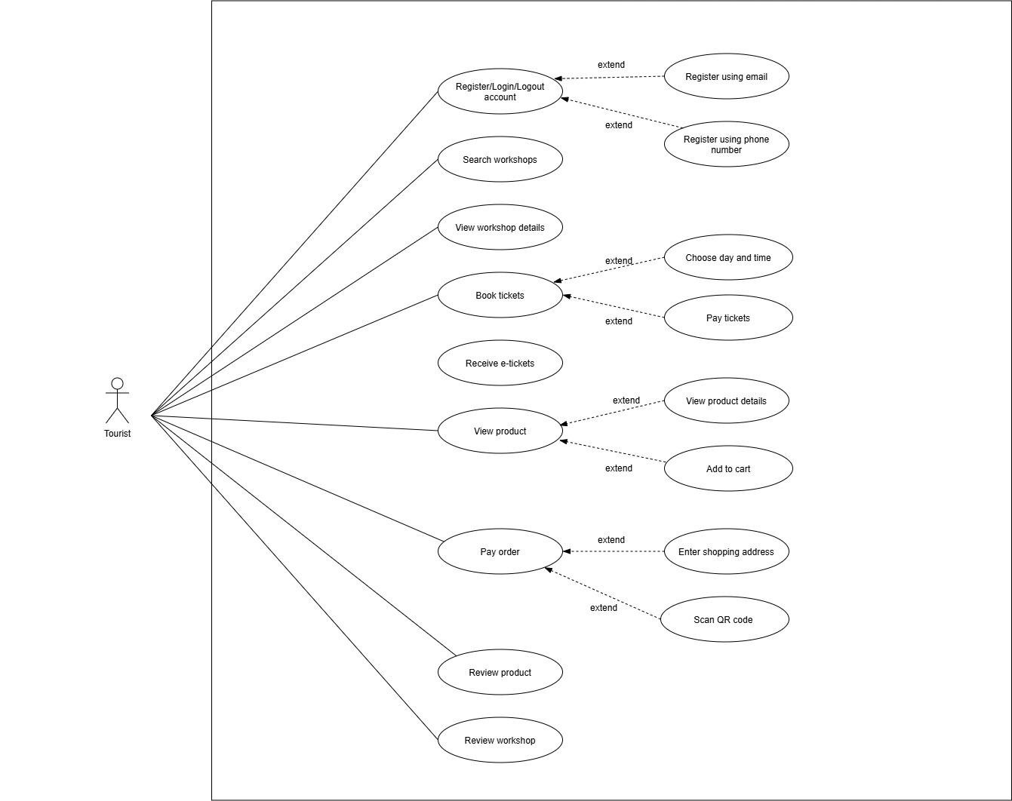
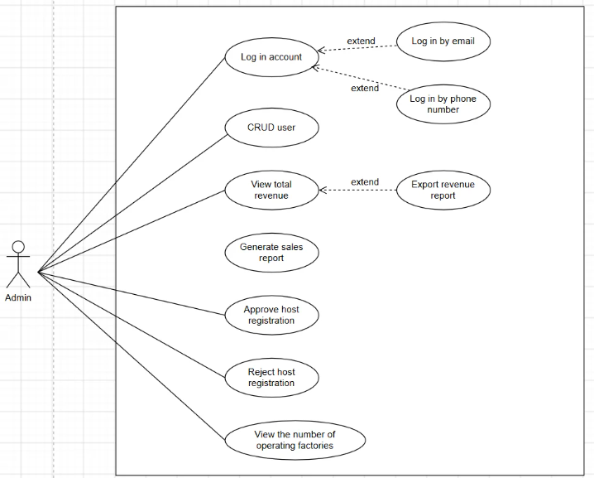

2.2.2. Descriptions

ID | Feature | Use Case | Use Case Description
01 | Authentication | Login Account | The user logs into the system using email or phone number.
02 | Authentication | Register Account | Users register a new account using email or phone number.
03 | User Management | CRUD User | Admin creates, views, updates, and deletes user accounts.
04 | Host Management | Approve Host Registration | Admin approves a host registration request.
05 | Host Management | Reject Host Registration | Admin rejects a host registration request.
06 | Revenue Management | View Total Revenue | Admin views the total revenue of the platform.
07 | Revenue Management | Generate Sales Report | Admin generates sales and revenue reports.
08 | Revenue Management | Export Revenue Report | Admin exports revenue reports for further analysis.
09 | Statistics Management | View Operating Statistics | Admin monitors operational statistics and system performance.
10 | Workshop Search | Search Workshops | Tourist searches for available workshops.
11 | Workshop Information | View Workshop Details | Tourists view detailed information about a workshop.
12 | Ticket Booking | Book Tickets | Tourists book tickets for a selected workshop.
13 | Ticket Booking | Choose Date and Time | The tourist selects the preferred workshop date and time.
14 | Payment | Pay Ticket | Tourists pay for workshop tickets.
15 | Ticket Management | Receive E-Tickets | Tourists receive electronic tickets after successful payment.
16 | Product Catalog | View Products | Tourists browse available products.
17 | Shopping Cart | Add to Cart | Tourists add products to the shopping cart.
18 | Shopping | Buy Product | Tourists purchase a product.
19 | Order Management | Enter Shipping Address | Tourist provides a shipping address for product delivery.
20 | Payment | Pay Order | Tourist completes payment for an order.
21 | Order Tracking | Track Order | Tourists track the status of an order.
22 | Review Management | Review Workshop | The tourist submits a review for a workshop.
23 | Review Management | Review Product | The tourist submits a review for a purchased product.
24 | Workshop Management | CRUD Workshop | Host creates, views, updates, and deletes workshops.
25 | Schedule Management | Create Time Slots | The host creates available time slots for workshops.
26 | Schedule Management | ScheduZZle Workshops | Host schedules workshops.
27 | Capacity Management | Set Guest Limits | The host sets the maximum number of participants.
28 | Revenue Management | View Revenue | Host views revenue generated from workshops and products.
29 | Product Management | CRUD Products | Host manages products by creating, viewing, updating, and deleting them.
30 | Order Management | View Order Details | The host views detailed information about customer orders.
31 | Notification Management | Send Order Notification | The host sends notifications regarding order updates.
32 | Order Management | Cancel Order | The host cancels an order when necessary.
33 | Profile Management | Update Personal Profile | Tour Guide updates personal profile information.
34 | Workshop Information | View Workshop Details | Tour Guide views assigned workshop details.
35 | Attendance Management | Check-in Customers | Tour Guide checks in customers upon arrival.
36 | Workshop Progress Management | Update Workshop Progress | Tour Guide updates the progress/status of an ongoing workshop.

3. Functional Requirements

3.1. System Functional Overview

3.1.1. Screens Flow
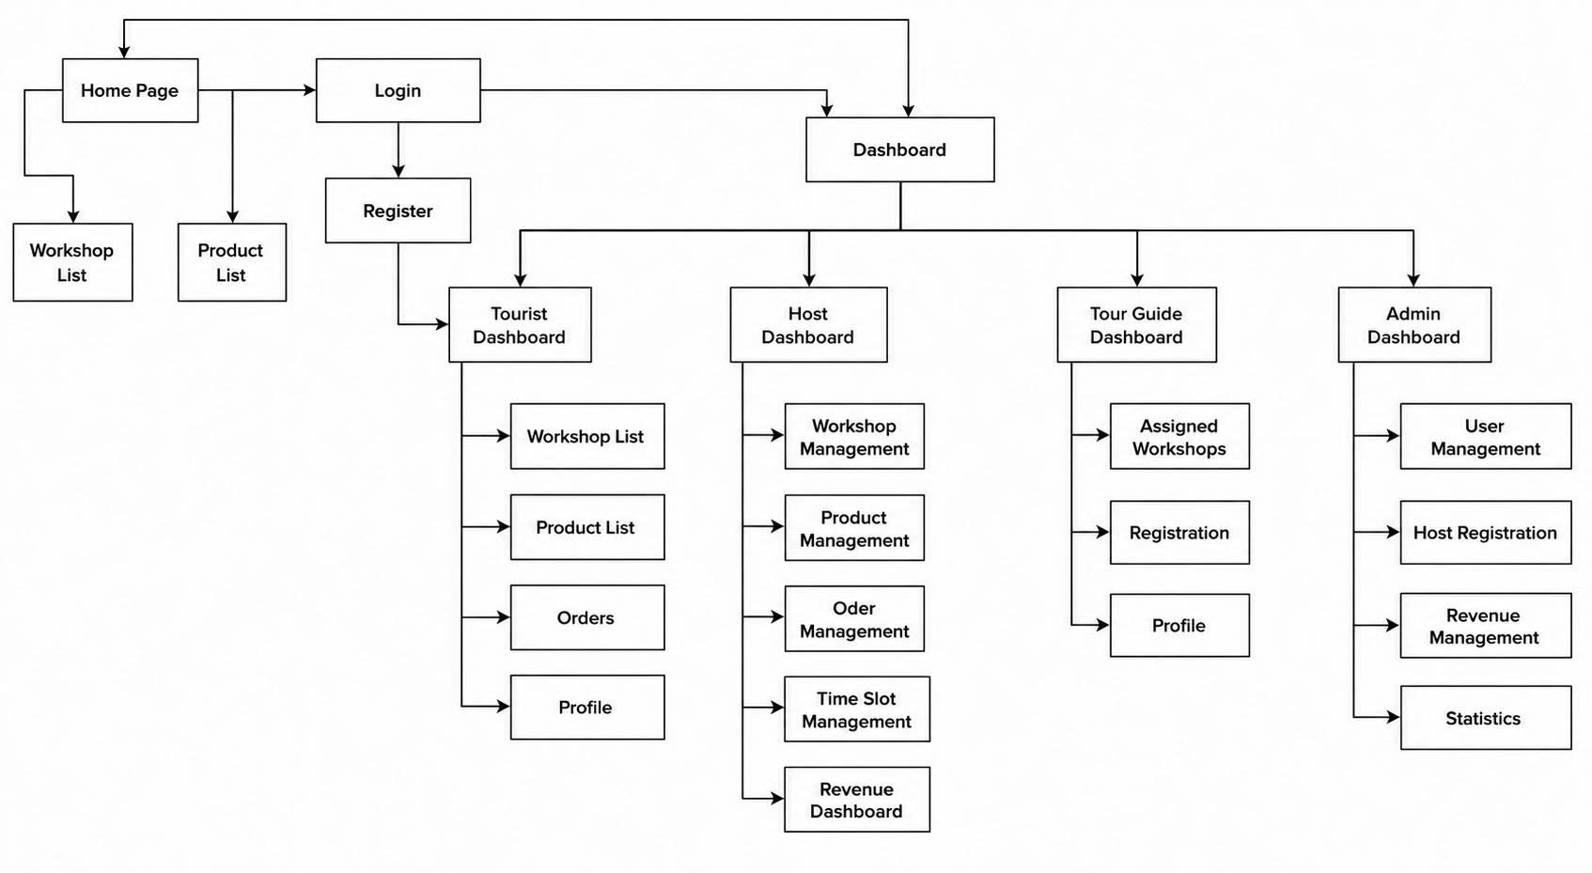
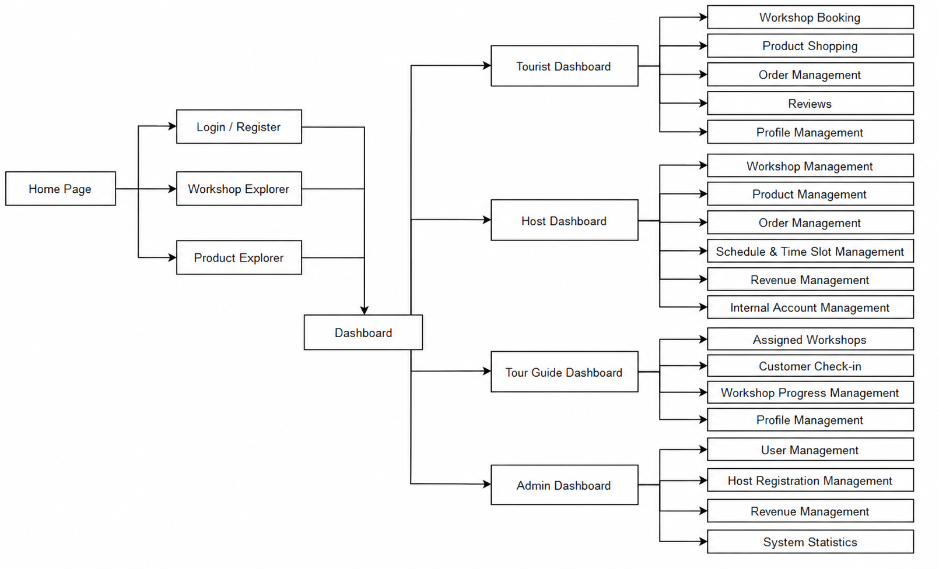

3.1.2. Screen Descriptions
# | Feature | Screen | Description
1 | Public Access | Home Page | Main landing screen that allows users to access workshop and product exploration, as well as login or registration.
2 | Authentication | Login / Register | Screen that allows users to sign in with their account or register a new account to access the platform.
3 | Workshop Discovery | Workshop Explorer | Screen that allows users to browse and explore available cultural workshops and view relevant workshop information.
4 | Product Shopping | Product Explorer | Screen that allows users to browse available local craft products and view product information.
5 | Dashboard | Dashboard | Central navigation screen that directs authenticated users to the dashboard corresponding to their assigned role.
6 | Tourist | Tourist Dashboard | Main dashboard for tourists, providing access to workshop booking, product shopping, orders, reviews, and profile management.
7 | Tourist | Workshop Booking | Screen that allows tourists to select a workshop, choose an available time slot, and make a booking.
8 | Tourist | Product Shopping | Screen that allows tourists to browse and purchase local craft products.
9 | Tourist | Order Management | Screen that allows tourists to view and manage their product orders and order information.
10 | Tourist | Reviews | Screen that allows tourists to view and submit reviews for completed workshop experiences.
11 | Tourist | Profile Management | Screen that allows tourists to view and update their personal account information.
12 | Host | Host Dashboard | Main dashboard for hosts, providing access to workshop, product, order, schedule, revenue, and account management functions.
13 | Host | Workshop Management | Screen that allows hosts to create, view, update, and manage their cultural workshops.
14 | Host | Product Management | Screen that allows hosts to manage local craft products, including product information and availability.
15 | Host | Order Management | Screen that allows hosts to view and manage customer product orders.
16 | Host | Schedule & Time Slot Management | Screen that allows hosts to create and manage workshop schedules, time slots, capacity, and availability.
17 | Host | Revenue Management | Screen that allows hosts to monitor revenue generated from workshop bookings and product sales.
18 | Host | Internal Account Management | Screen that allows hosts to manage internal accounts and related staff information.
19 | Tour Guide | Tour Guide Dashboard | Main dashboard for tour guides, providing access to assigned workshops, customer check-in, workshop progress, and profile functions.
20 | Tour Guide | Assigned Workshops | Screen that allows tour guides to view workshops and schedules assigned to them by hosts.
21 | Tour Guide | Customer Check-in | Screen that allows tour guides to verify customer QR e-tickets and record customer check-in.
22 | Tour Guide | Workshop Progress Management | Screen that allows tour guides to update the progress or status of an ongoing workshop session.
23 | Tour Guide | Profile Management | Screen that allows tour guides to view and update their personal profile information.
24 | Admin | Admin Dashboard | Main dashboard for administrators, providing access to user, host registration, revenue, and system statistic management.
25 | Admin | User Management | Screen that allows administrators to view and manage platform user accounts, including account status.
26 | Admin | Host Registration Management | Screen that allows administrators to review and approve host registration requests.
27 | Admin | Revenue Management | Screen that allows administrators to monitor platform revenue and transaction-related information.
28 | Admin | System Statistics | Screen that allows administrators to monitor overall platform statistics and operational data.

3.1.3. Screen Authorization
# | Screen | Host | Tourist | Tour Guide | Admin
1 | Order Management (Tourist) |  | X
2 | Product Explorer | X | X | X | X
3 | Profile Management (Tour Guide) |  |  | X
4 | Reviews |  | X
5 | Home Page | X | X | X | X
6 | Workshop Explorer | X | X | X | X
7 | Workshop Booking |  | X
8 | Internal Account Management | X
9 | Forgot Password | X | X | X | X
10 | Profile Management (Tourist) |  | X
11 | Product Shopping |  | X
12 | Tourist Dashboard |  | X
13 | Customer Check-in |  |  | X
14 | Logout | X | X | X | X
15 | Schedule & Time Slot Management | X
16 | Assigned Workshops |  |  | X
17 | Host Registration Management |  |  |  | X
18 | Host Dashboard | X
19 | Dashboard | X | X | X | X
20 | Revenue Management (Admin) |  |  |  | X
21 | Order Management (Host) | X
22 | Product Management | X
23 | Login / Register | X | X | X | X
24 | Admin Dashboard |  |  |  | X
25 | Revenue Management (Host) | X
26 | Workshop Management | X
27 | Tour Guide Dashboard |  |  | X
28 | System Statistics |  |  |  | X
29 | Workshop Progress Management |  |  | X
30 | User Management |  |  |  | X

3.1.5 Entity Relationship Diagram

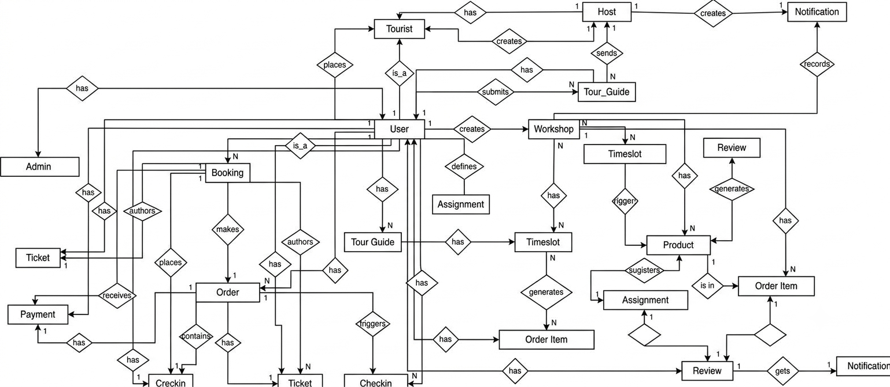
Entities Description
# | Entity | Description
1 | User | Represents a system user account (used by Tourist, Host, Tour Guide, Admin). Stores personal details, email, password hash, avatar, phone number, role, Google ID, and account status
2 | Tourist | Represents a tourist profile linked to a user account. Contains personal details including date of birth and address.
3 | Host | Represents a workshop host or business owner linked to a user account. Stores business details, business image, address, contact phone, and approval status.
4 | TourGuide | Represents a tour guide profile linked to a user account. Contains biography, work experience, spoken languages, and system approval status.
5 | Admin | Represents a workshop event created and organized by a host. Stores title, description, location, address, price, duration, maximum participants, image, and active status.
6 | Workshop | Represents a specific time session allocated for a workshop. Stores start time, end time, participant capacity, available spots, and active status.
7 | Timeslot | Represents the academic grade/class of a student. Used to categorize students by education level (e.g., Grade 6, Grade 7).
8 | Booking | Represents a workshop reservation made by a tourist for a specific timeslot. Contains participant count, total amount, and booking status.
9 | Ticket | Represents an entry ticket generated for a confirmed booking. Stores a unique QR code, ticket status, and usage timestamp.
10 | Assignment | Represents the assignment record linking a tour guide to manage a specific workshop timeslot.
11 | Schedule | Represents a check-in verification performed by a tour guide for a booking. Tracks check-in time, status, and optional notes.
12 | Checkin | Represents a check-in verification performed by a tour guide for a booking. Tracks check-in time, status, and optional notes.
13 | Review | Represents feedback and rating submitted by a tourist for a workshop. Stores rating score (1-5), comments, and creation date.
14 | Product | Represents a handcrafted product listed for sale by a host. Stores name, description, price, stock quantity, product images, and active status.
15 | Order | Represents a product purchase transaction placed by a tourist. Tracks total amount, order status, payment status, payment method, and PayOS order code.
16 | OrderItem | Represents an individual item within a product order. Stores the linked product ID, purchased quantity, and unit price.
17 | Payment | Represents a payment transaction record for an order. Stores payment amount, PayOS transaction codes, payment status, completion time, and raw gateway response data.
18 | Notification | Represents a notification message sent to a user. Stores title, content message, type, read status, and timestamp.

3.2. Authentication

3.2.1. Login/logout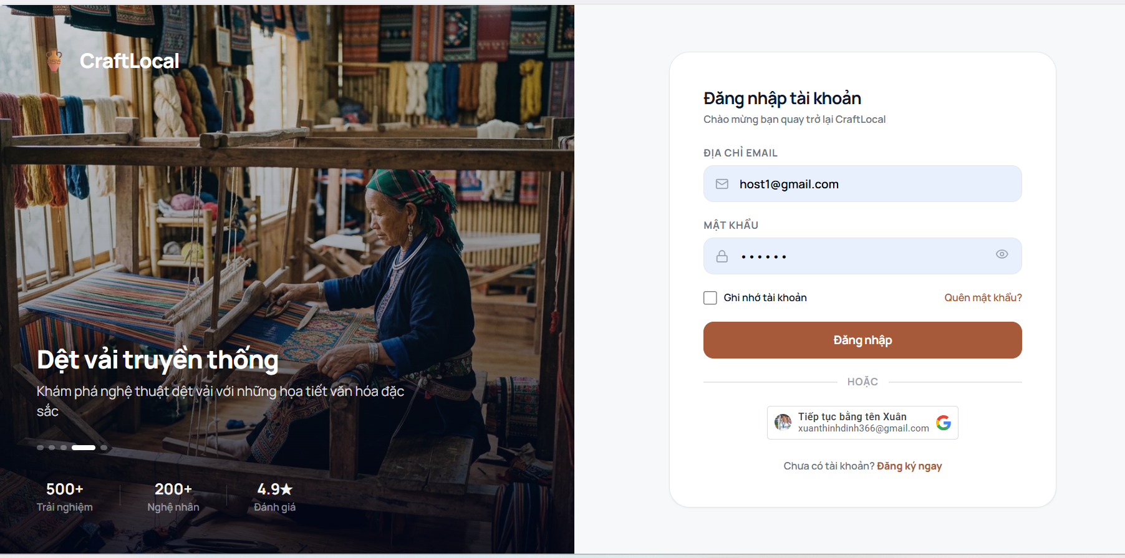

Function trigger:
The user navigates to the Login page and submits their email and password, or chooses to continue with Google.
Function description:
Actors: Host, Tourist, Tour Guide, Admin
Purpose: Allow users to authenticate their accounts and gain access to the appropriate system functions based on their assigned role.
Data Processing:
- Validate the entered email and password fields.
- Verify the email and password against the stored user account records.
- If the credentials are valid, authenticate the user and create a session/token.
- Determine the user's assigned role.
- Redirect the user to the corresponding dashboard based on their role.
- If the credentials are invalid, display an authentication error message.
- If the user selects Forgot Password, navigate to the password recovery process.
- If the user selects Continue with Google, authenticate the user through the Google authentication service.

3.2.2. Register Account
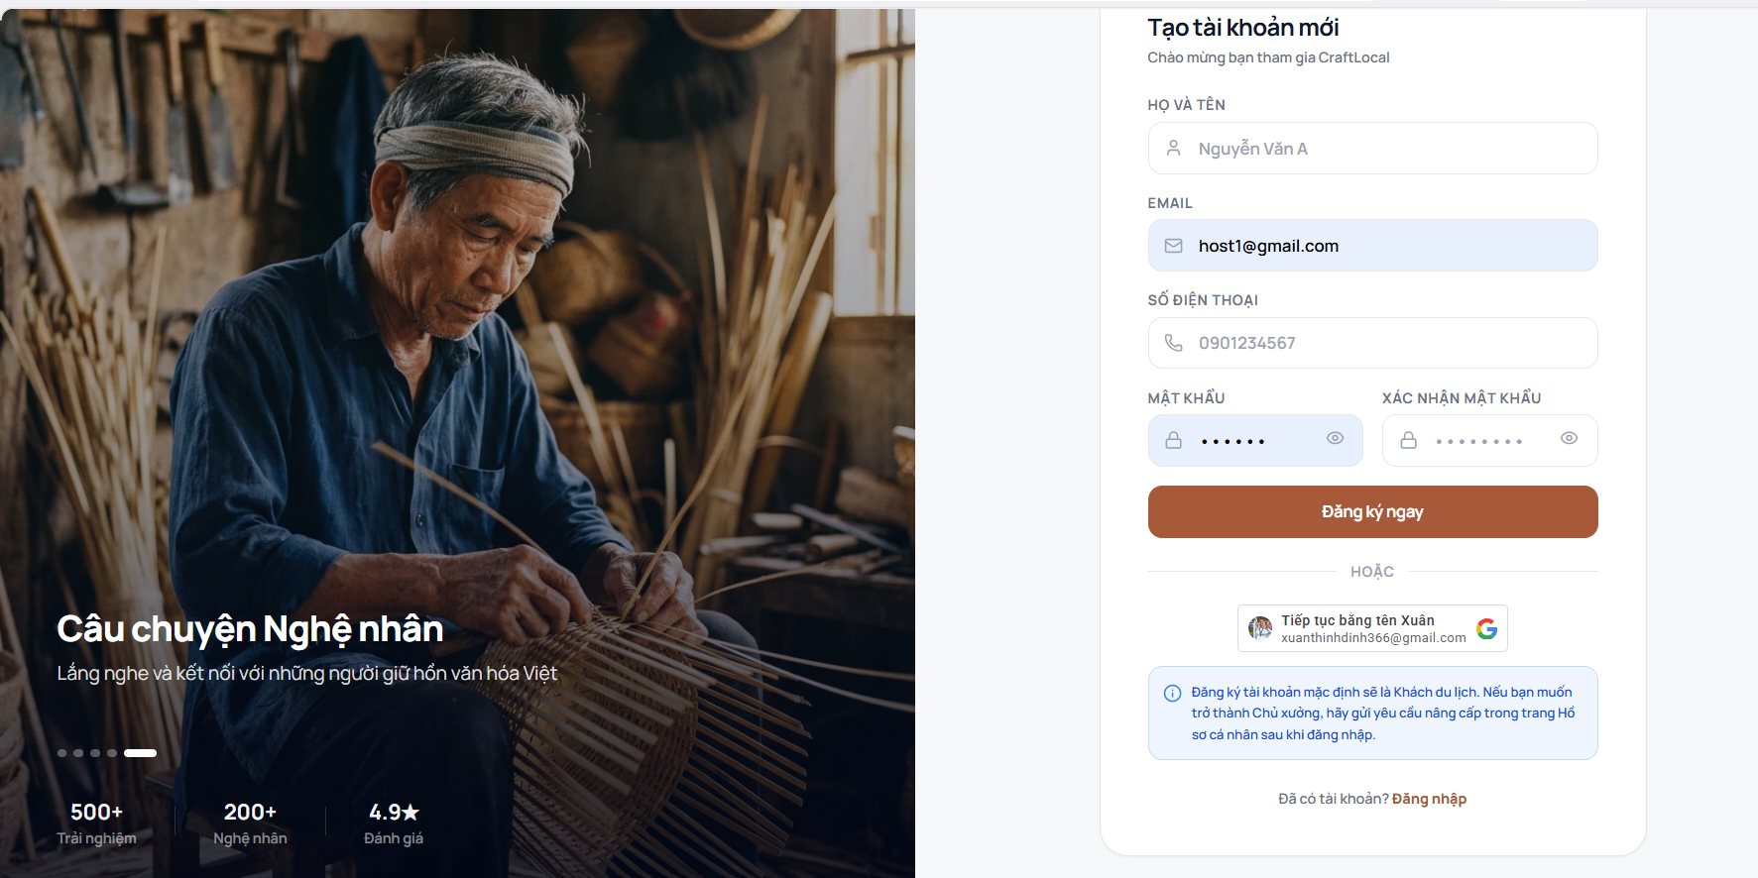
Function trigger:
The user navigates to the registration page and submits their full name, email, phone number, password, and password confirmation, or chooses to continue with Google.
Function description:
Actors: Host, Tourist, Tour Guide, Admin
Purpose: Allow new users to create an account and register for access to the CraftLocal platform.
Data Processing:
- Validate all required fields, including full name, email, phone number, password, and password confirmation.
- Validate the email format and check whether the email is already associated with an existing account.
- Verify that the password and confirmation password match.
- Create a new user account with the provided information.
- Assign Tourist as the default account role, as indicated on the registration screen.
- Store the new account information in the user records.
- If the user selects Continue with Google, authenticate and create the account using the Google authentication service.
- After successful registration, allow the user to log in and access the Tourist functions.
- If the user wants to become a Host, they can submit a Host registration request from their profile after logging in.

3.2.3. Forgot/Change Password

3.3. User Management

3.3.1. CRUD User
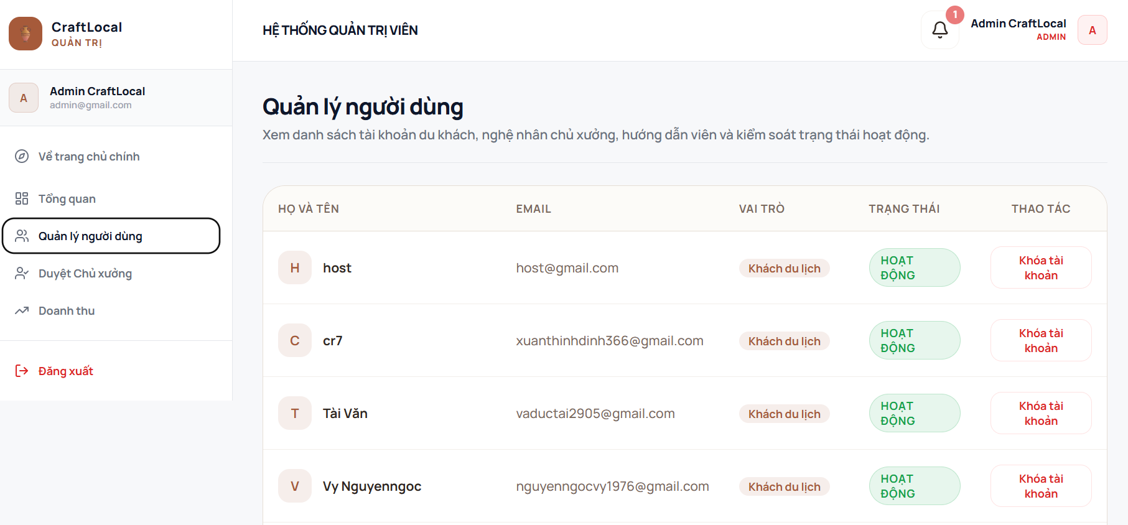
Function trigger:
Admin navigates to the User Management section from the administrator dashboard and views or manages registered user accounts.
Function description:
Actors: Admin
Purpose: Allow administrators to view registered user accounts, review account information and control the active status of platform users.
Data Processing:
- Retrieve registered user accounts from the user records.
- Display user information including full name, email, role, and account status.
- Allow the Admin to review the current status of each user account.
- When the Admin selects Lock Account, update the selected user's account status to inactive/locked.
- Prevent or restrict access for users whose accounts have been locked.
- Update the displayed account status after the action is completed.

3.3.2. Profile Management
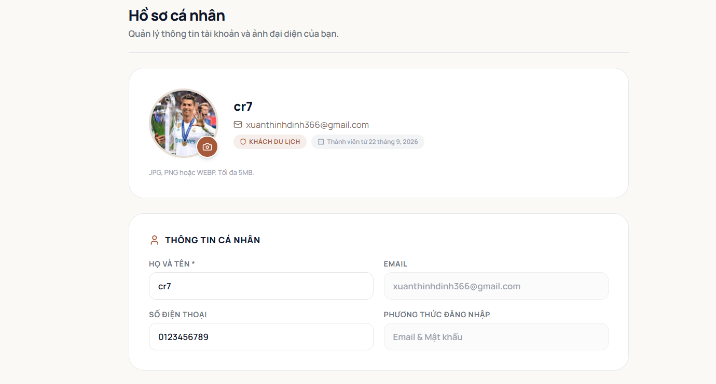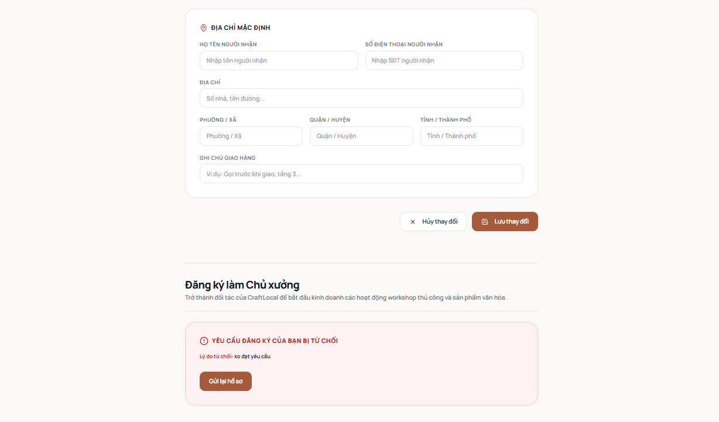

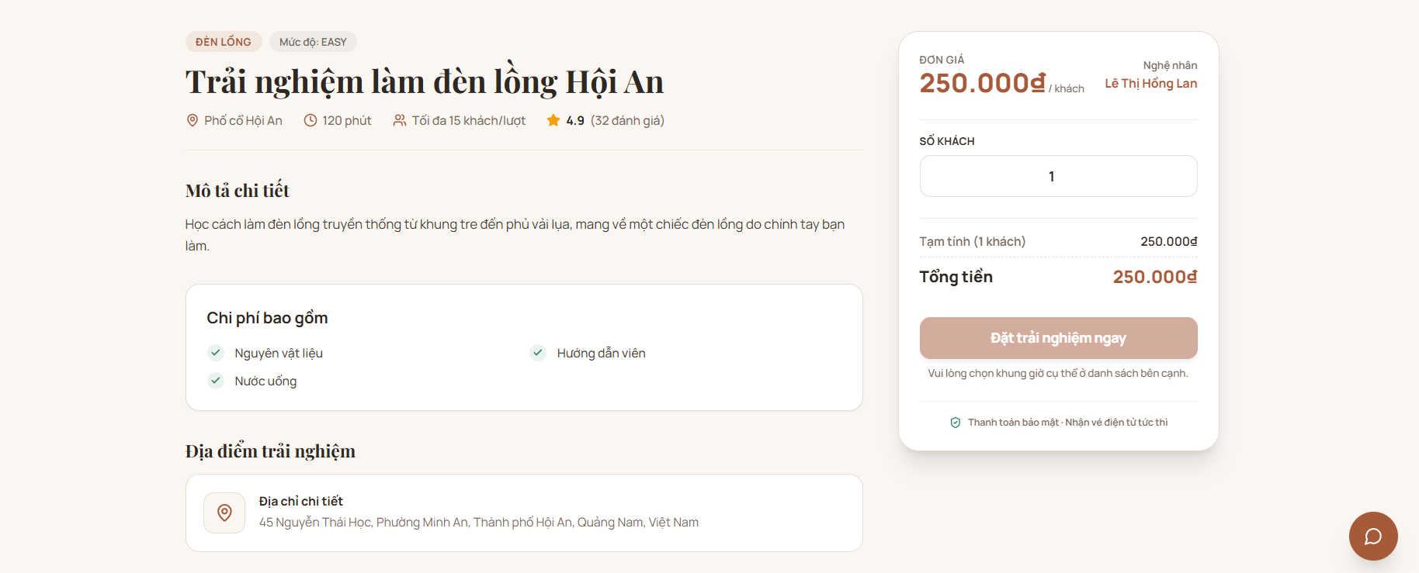
Function trigger: User views the experience details page, selects the number of guests, and clicks the "Đặt trải nghiệm ngay" button.
Function description:
Actors: Customer (User / Guest), Guest
Purpose: Display experience details (title, price, artisan info, duration, location, included fees) and allow users to select the quantity of guests and proceed to booking/checkout.
Data Processing:
- Fetch & Display Data:
  - Load and display experience metadata: Title ("Trải nghiệm làm đèn lồng Hội An"), tags, difficulty level ("EASY"), location, duration ("120 phút"), group size limit ("Tối đa 15 khách/lượt"), rating & review count ("4.9 (32 đánh giá)").
  - Display detail description, included expenses (materials, instructor, water), full address, artisan name ("Lê Thị Hồng Lan"), base price per guest ("250.000đ/khách"), and gallery images.
- Input & Subtotal Calculation:
  - Allow user to adjust the number of guests ("SỐ KHÁCH").
  - Validate input: Ensure the number of guests is a positive integer and does not exceed the maximum capacity per slot (<= 15 guests).
  - Dynamically calculate subtotal and total price (Total = Unit Price × Number of Guests).
- Booking Redirection:
  - When the user clicks "Đặt trải nghiệm ngay", validate that required selections (such as slot/time if applicable) are fulfilled.
  - If valid, store selected parameters (experience ID, guest count, calculated total price) and redirect the user to the checkout/time-selection flow.

3.3.4. Shopping Cart and Payment
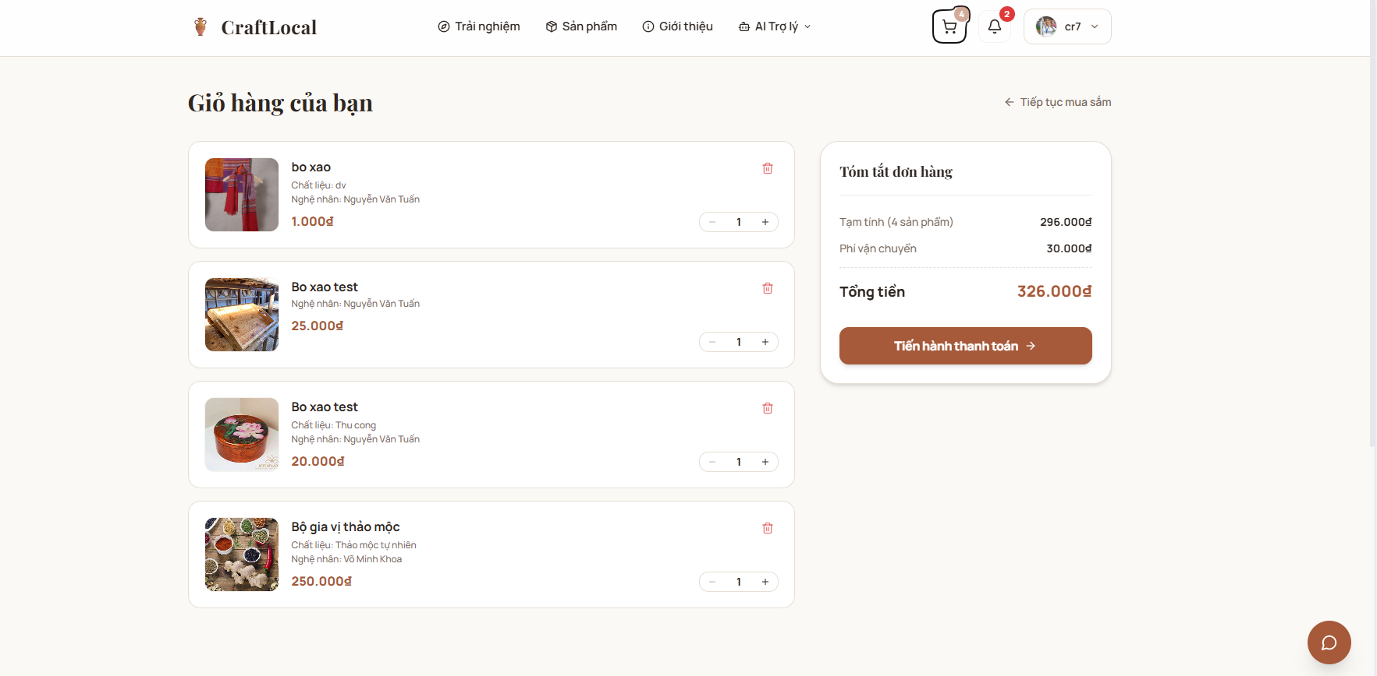
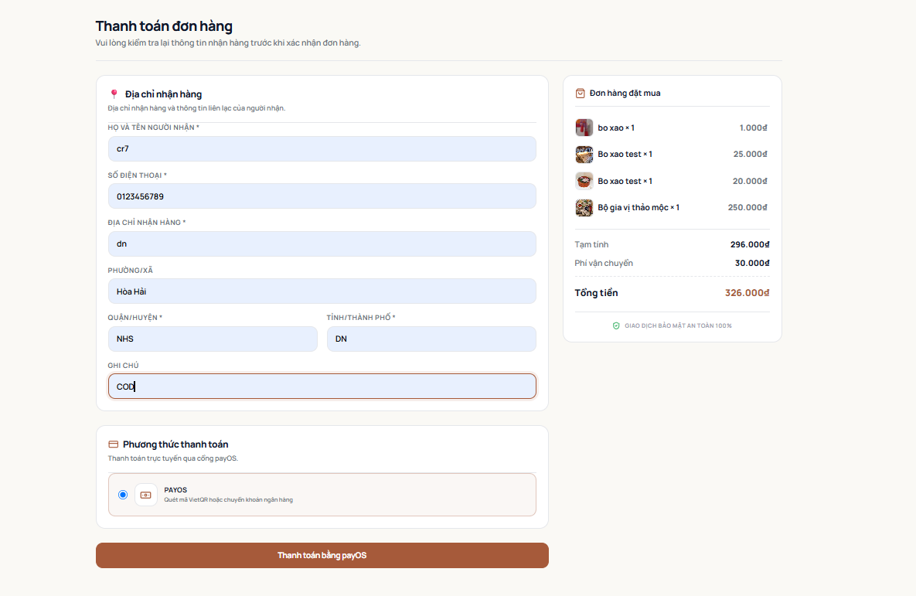
Function trigger: User navigates to the cart page or clicks on the cart icon in the header to view and manage selected products.
Function description:
Actors: Customer (User / Guest)
Purpose: Display all items added to the cart, allow users to update item quantities or remove items, dynamically calculate total costs, and proceed to checkout.
Data Processing:
- Fetch & Display Cart Items:
  - Load and render the list of items currently in the cart with details: product image, product name, material/attributes (e.g., "Chất liệu: Thu cong"), artisan name, unit price, and current quantity.
  - Display header cart badge counter (e.g., badge showing count of items in cart).
- Cart Item Management & Dynamic Calculation:
  - Quantity Adjustment: Allow users to increase (+) or decrease (-) the quantity for each item.
    - Validate input: Ensure quantity is a positive integer (>= 1).
  - Item Removal: Allow users to click the trash/delete icon to remove a specific item from the cart.
  - Order Summary Calculation: Dynamically recalculate and update:
    - Subtotal (Tạm tính) based on selected quantities and unit prices.
    - Shipping Fee (Phí vận chuyển).
    - Grand Total (Tổng tiền = Tạm tính + Phí vận chuyển).
- Navigation & Proceeding to Checkout:
  - If user clicks "Tiếp tục mua sắm", navigate back to the product/experience catalog.
  - If the user clicks "Tiến hành thanh toán", validate that the cart is not empty, save the cart state, and redirect the user to the checkout page.

3.4. Host Management

3.4.1. Approve Host Registration
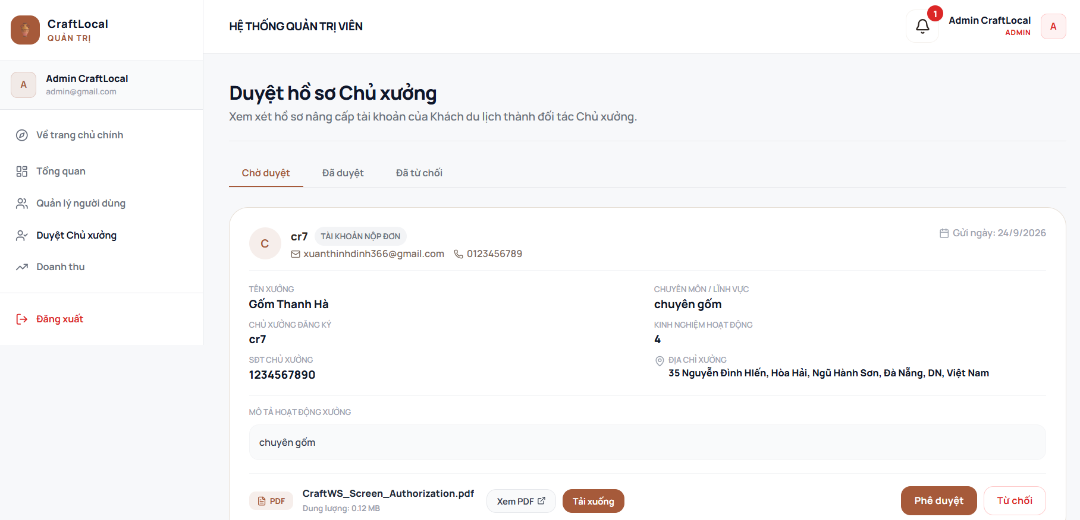

Function Details:
Validation:
● User must be authenticated Admin
● Sort criteria must be valid
Business Rules:
● Users are sorted by creation date (newest first) by default
● All users are displayed regardless of status
Functionalities
Normal case:
1. Admin navigates to User Management page
2. System loads all users with pagination
3. System displays user statistics
4. Admin can search, filter, and sort users
5. Admin can view user details by clicking "View"
6. Admin can edit users by clicking "Edit"
Abnormal case:
1. If search returns no results: System shows message "No users match

3.4.2. Reject Host Registration
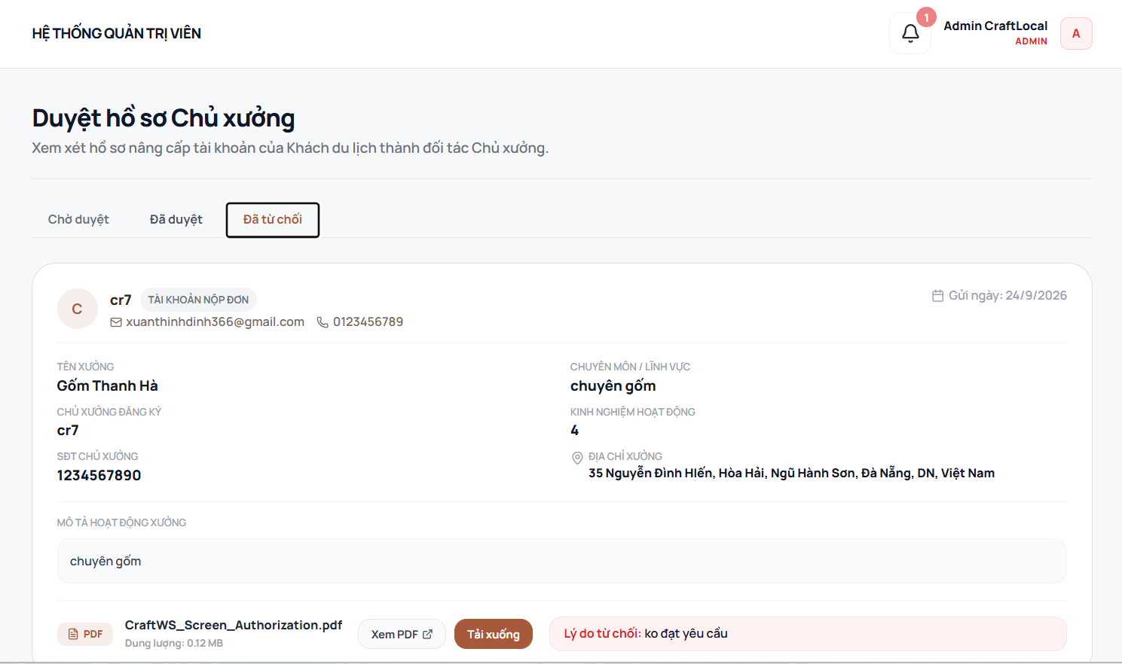
Function trigger:
Admin navigates to the Host Registration Management screen and selects a registration request to review its submitted information.
Function description:
Actors: Admin
Purpose: Allow administrators to review and manage account upgrade requests from tourists who want to become Hosts.
Data Processing:
- Retrieve Host registration requests from the registration records.
- Display the applicant's submitted information, including name, email, phone number, workshop name, specialization, experience, address, and activity description.
- Categorize registration requests by status, such as Pending, Approved, and Rejected.
- Allow the Admin to review the submitted application and attached supporting documents.
- If the application is approved, update the registration status and upgrade the applicant's account to the Host role.
- If the application is rejected, update the registration status and record the rejection reason.
- Store the decision and updated application status for future reference.

3.4.3. Product Upload By Host
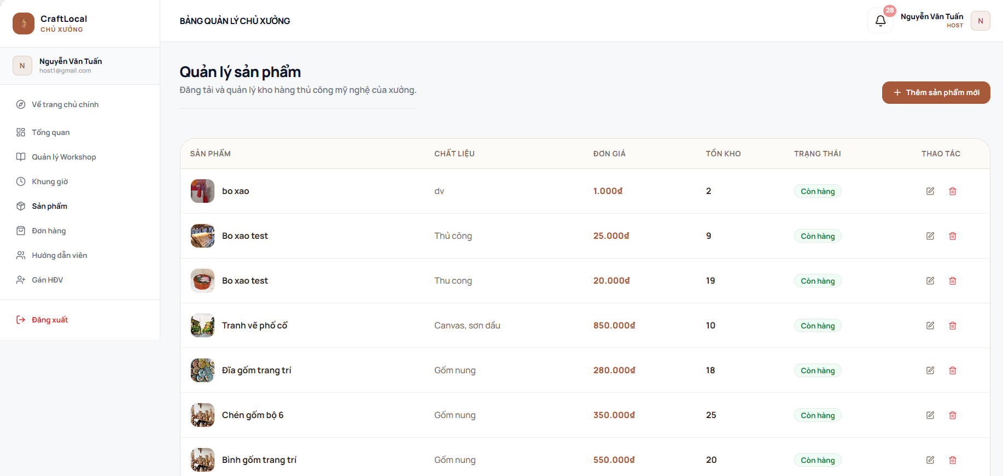
Function trigger: Host accesses the "Sản phẩm" menu item from the sidebar navigation in the Host Dashboard.
Function description:
Actors: Host (Chủ xưởng / Nghệ nhân)
Purpose: Allow hosts to view, add, edit, track stock inventory, and delete handicraft product listings of their workshop.
Data Processing:
- Fetch & Display Product List:
  - Load and display table of handicraft products with fields: Product Image & Name ("SẢN PHẨM"), Material/Attributes ("CHẤT LIỆU", e.g., "Thủ công", "Gốm nung", "Canvas, sơn dầu"), Unit Price ("ĐƠN GIÁ"), Stock Quantity ("TỔN KHO"), Inventory Status ("TRẠNG THÁI", e.g., "Còn hàng"), and Action Controls ("THAO TÁC").
- Create New Product:
  - When the host clicks "+ Thêm sản phẩm mới", open a form/modal to enter new product details (product name, description, material, price, stock count, product images).
- Product Management Actions:
  - Edit Product (Icon bút): Open the edit modal/form pre-filled with selected product data to update details (name, material, price, stock count).
  - Delete Product (Icon thùng rác): Prompt confirmation dialog to permanently delete the product listing from the inventory and store.

3.4.4. Order Management By Host
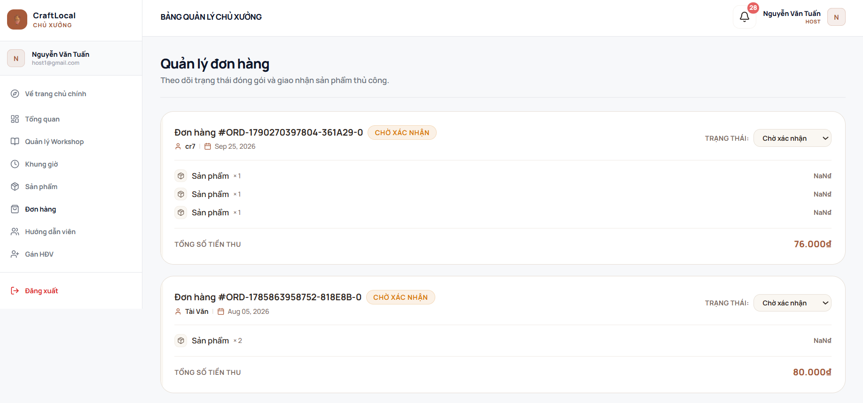
Function trigger: Host accesses the "Đơn hàng" menu item from the sidebar navigation in the Host Dashboard.
Function description:
Actors: Host (Chủ xưởng / Nghệ nhân)
Purpose: Allow hosts to view product orders, track order items, monitor payment totals, and update fulfillment/order statuses.
Data Processing:
- Fetch & Display Order List:
  - Load and display order cards containing order ID (e.g., "#ORD-1790270397804-361A29-0"), customer name, order creation date, current status badge (e.g., "CHỜ XÁC NHẬN"), and total revenue ("TỔNG SỐ TIỀN THU").
  - Render list of purchased items within each order card (product name, quantity purchased, and item price).
- Update Order Status:
  - Provide a status dropdown control ("TRẠNG THÁI") for each order card.
  - When the host selects a new status from the dropdown (e.g., changing from "Chờ xác nhận" to processing/delivering/completed), update order record in database and refresh status badge in real-time.

3.4.5. Assigning Tour Guides
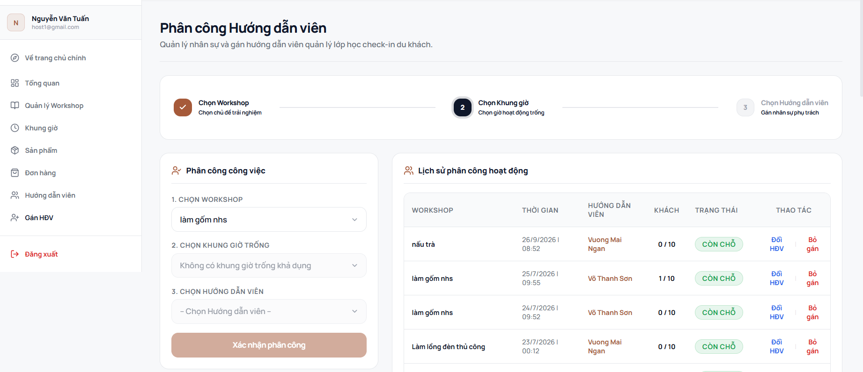
Function trigger: Host accesses the "Gán HDV" menu item from the sidebar navigation in the Host Dashboard.
Function description:
Actors: Host (Chủ xưởng / Nghệ nhân)
Purpose: Allow hosts to assign instructors/tour guides to specific workshop time slots and track/manage existing assignments.
Data Processing:
- Stepped Assignment Form:
  - Step 1 - Select Workshop: Allow host to select a workshop from the dropdown list ("CHỌN WORKSHOP", e.g., "làm gốm nhs").
  - Step 2 - Select Available Time Slot: Dynamically filter and populate available time slots for the selected workshop ("CHỌN KHUNG GIỜ TRỐNG"). If no open slots exist, display appropriate message (e.g., "Không có khung giờ trống khả dụng").
  - Step 3 - Select Instructor: Choose an instructor/tour guide from the staff list ("CHỌN HƯỚNG DẪN VIÊN").
  - Submit Assignment: Validate that all 3 steps are selected before enabling "Xác nhận phân công". Upon submission, save the assignment record and update the assignment history.
- Display Assignment History:
  - Fetch and render historical and active assignments table: Workshop Name, Date & Time ("THỜI GIAN"), Assigned Instructor ("HƯỚNG DẪN VIÊN"), Guest Count ("KHÁCH"), Slot Status ("TRẠNG THÁI", e.g., "CÒN CHỖ"), and Quick Actions ("THAO TÁC").
- Quick Action Controls:
  - Đổi HDV (Change Instructor): Open dialog to change assigned instructor for the specific slot.
  - Bỏ gán (Unassign): Prompt confirmation dialog to remove the instructor assignment from the time slot.

3.4.6. Factory Owner Overview
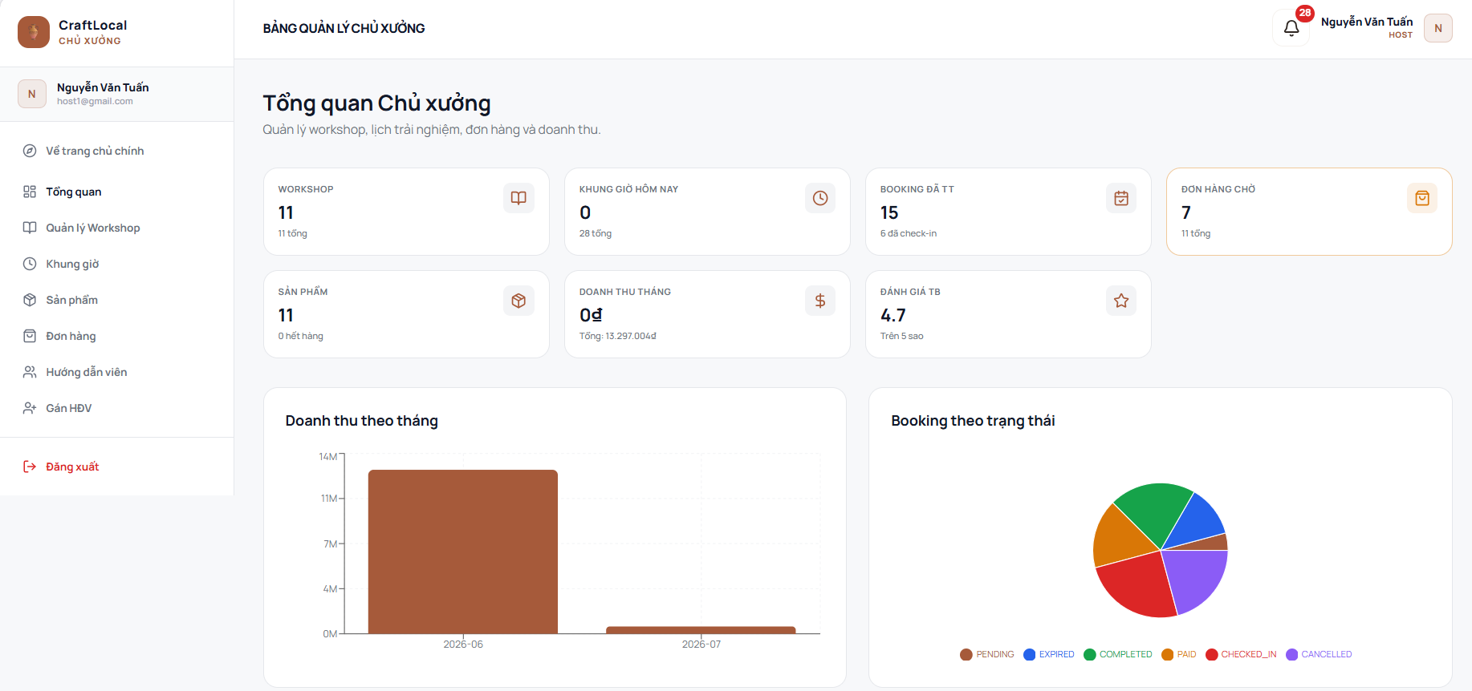
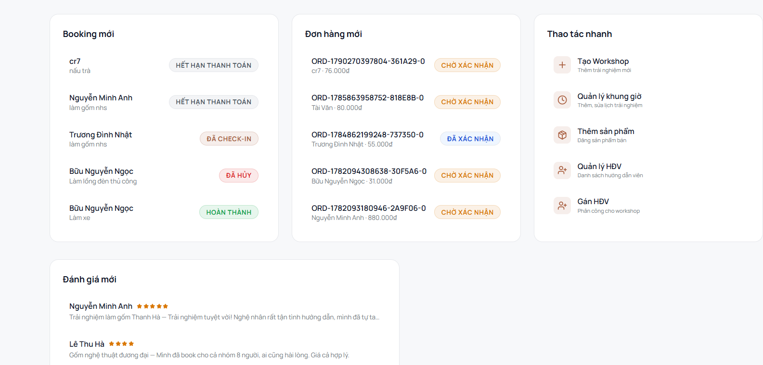
Function trigger: Host logs into the system or clicks on the "Tổng quan" item in the sidebar navigation.
Function description: Actors: Host (Chủ xưởng / Nghệ nhân)
Purpose: Provide host with a high-level overview of workshop metrics, revenue statistics, booking statuses, recent activities, latest reviews, and quick access shortcuts to management tasks.
Data Processing:
- Metric Cards Aggregation:
  - Fetch and display key operational KPIs: Total Workshops ("WORKSHOP"), Today's Time Slots ("KHUNG GIỜ HÔM NAY"), Paid Bookings ("BOOKING ĐÃ TT"), Pending Orders ("ĐƠN HÀNG CHỜ"), Active Products ("SẢN PHẨM"), Monthly Revenue ("DOANH THU THÁNG"), and Average Rating ("ĐÁNH GIÁ TB").
- Data Visualization & Analytics:
  - Monthly Revenue Bar Chart: Render monthly financial revenue trend over time (e.g., comparing months 2026-06 and 2026-07).
  - Booking Status Donut Chart: Calculate and visually render booking status distribution breakdown (PENDING, EXPIRED, COMPLETED, PAID, CHECKED_IN, CANCELLED).
- Real-time Activity Feeds:
  - Recent Bookings List: Display latest experience bookings with customer name, workshop title, and real-time status badge (HẾT HẠN THANH TOÁN, ĐÃ CHECK-IN, ĐÃ HỦY, HOÀN THÀNH).
  - Recent Product Orders List: Display latest physical product orders with order code, customer name, price, and status badge (CHỜ XÁC NHẬN, ĐÃ XÁC NHẬN).
  - Recent Reviews List: Load and render user feedback containing customer name, star rating, experience title, and review comments.
- Quick Action Shortcuts:
  - Provide direct navigation links for frequent tasks: "Tạo Workshop", "Quản lý khung giờ", "Thêm sản phẩm", "Quản lý HDV", and "Gán HDV".

3.5. Revenue Management

3.5.1. View Total Revenue
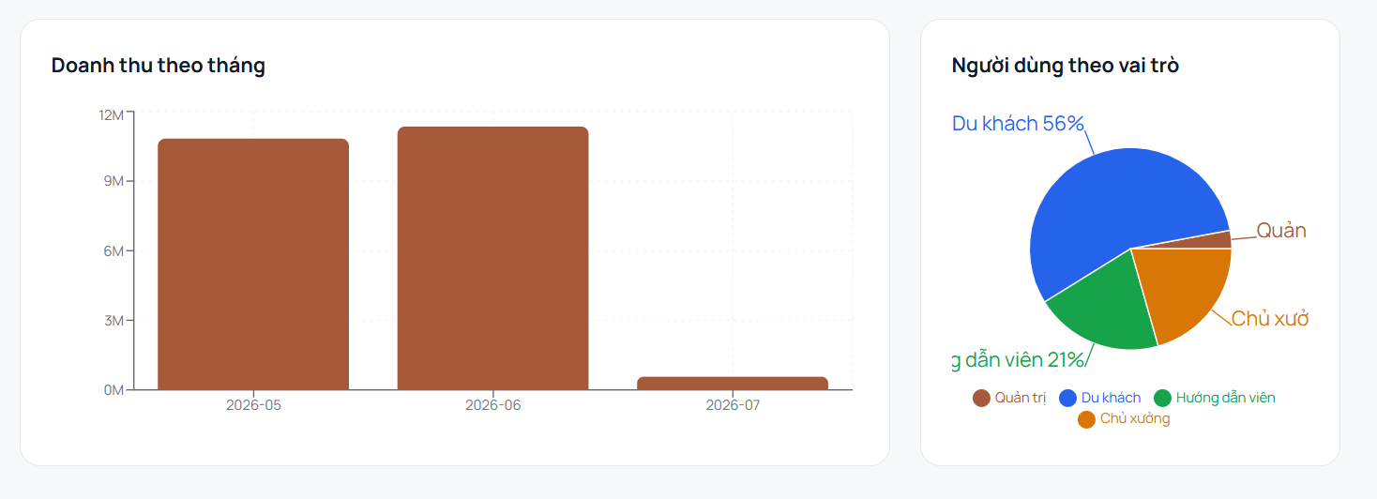
Function trigger:
Admin navigates to the Revenue or System Statistics section from the administrator dashboard to monitor platform revenue and user statistics.
Function description:
Actors: Admin
Purpose: Allow administrators to monitor monthly platform revenue and analyze the distribution of users by role.
Data Processing:
- Retrieve transaction and revenue data from the system records.
- Aggregate revenue by month and calculate the corresponding total revenue.
- Display monthly revenue in a chart for the selected period.
- Retrieve user account data and group users according to their assigned roles.
- Calculate the number or percentage of users for each role, including Tourist, Host, Tour Guide, and Admin.
- Display the user distribution by role in a chart.
- Update the displayed statistics when the underlying revenue or user data changes.

3.5.2. Generate Sales Report
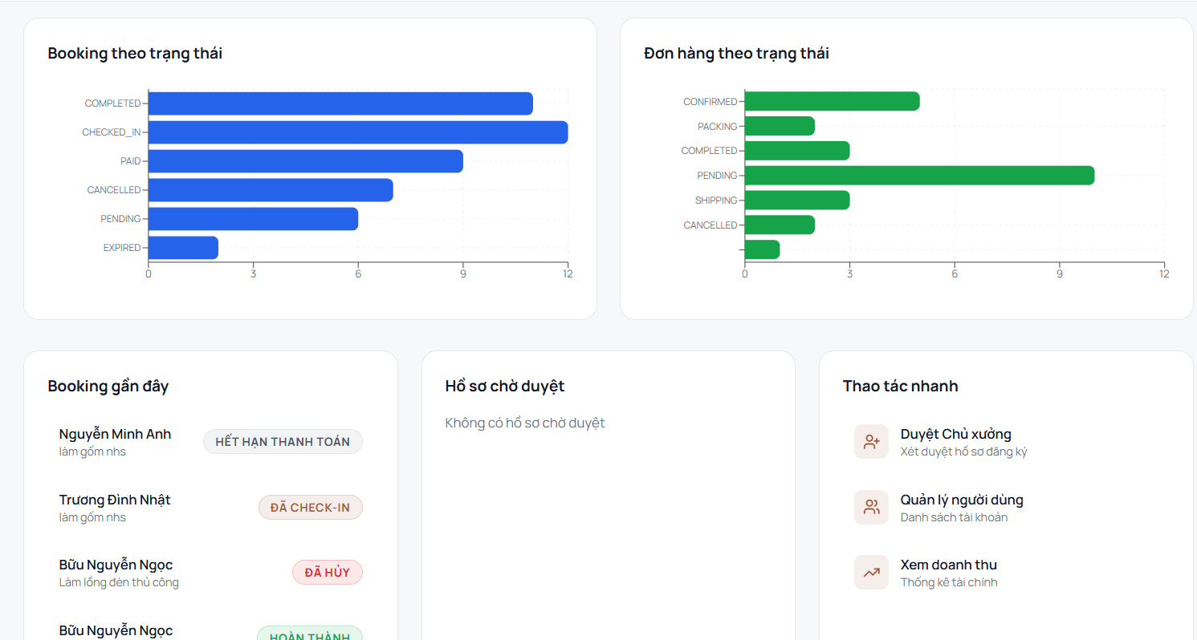
Function trigger:
Admin navigates to the Admin Dashboard to monitor booking and order statuses, review recent activities, and access administrative functions.
Function description:
Actors: Admin
Purpose: Provide administrators with an overview of platform operations and quick access to user, Host registration, and revenue management functions.
Data Processing:
- Retrieve booking records and group them by status, including Pending, Paid, Checked-in, Completed, Cancelled, and Expired.
- Retrieve order records and group them by status, including Pending, Confirmed, Packing, Shipping, Completed, and Cancelled.
- Retrieve recent booking records and display relevant customer, workshop, and booking status information.
- Retrieve pending Host registration requests and display their current status.
- Provide quick access to Host Registration Management for reviewing Host applications.
- Provide quick access to User Management for managing user accounts.
- Provide quick access to Revenue Management for viewing financial statistics.
- Update dashboard statistics based on the latest booking, order, and registration data.

3.5.3. Export Revenue Report

3.5.4. Statistics Management
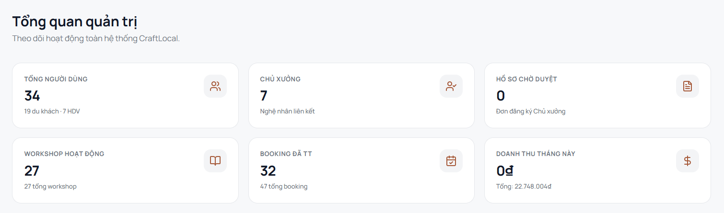
Function trigger:
Admin navigates to the Admin Overview screen to monitor the overall operational status of the CraftLocal system.
Function description:
Actors: Admin
Purpose: Provide administrators with a summarized view of key system metrics, including users, Hosts, pending Host applications, active workshops, completed bookings, and monthly revenue.
Data Processing:
- Retrieve user account records and calculate the total number of users, including Tourist and Tour Guide accounts.
- Retrieve Host records and calculate the total number of active Hosts.
- Retrieve Host registration requests and count the applications currently waiting for approval.
- Retrieve workshop records and calculate the number of active workshops.
- Retrieve booking records and calculate the number of completed bookings and total bookings.
- Retrieve transaction and revenue records and calculate the revenue for the current month.
- Display the calculated metrics in the corresponding overview cards.
- Update the displayed statistics based on the latest system data.

3.6. Ticket Management

3.6.1. Ticket Booking and Payment
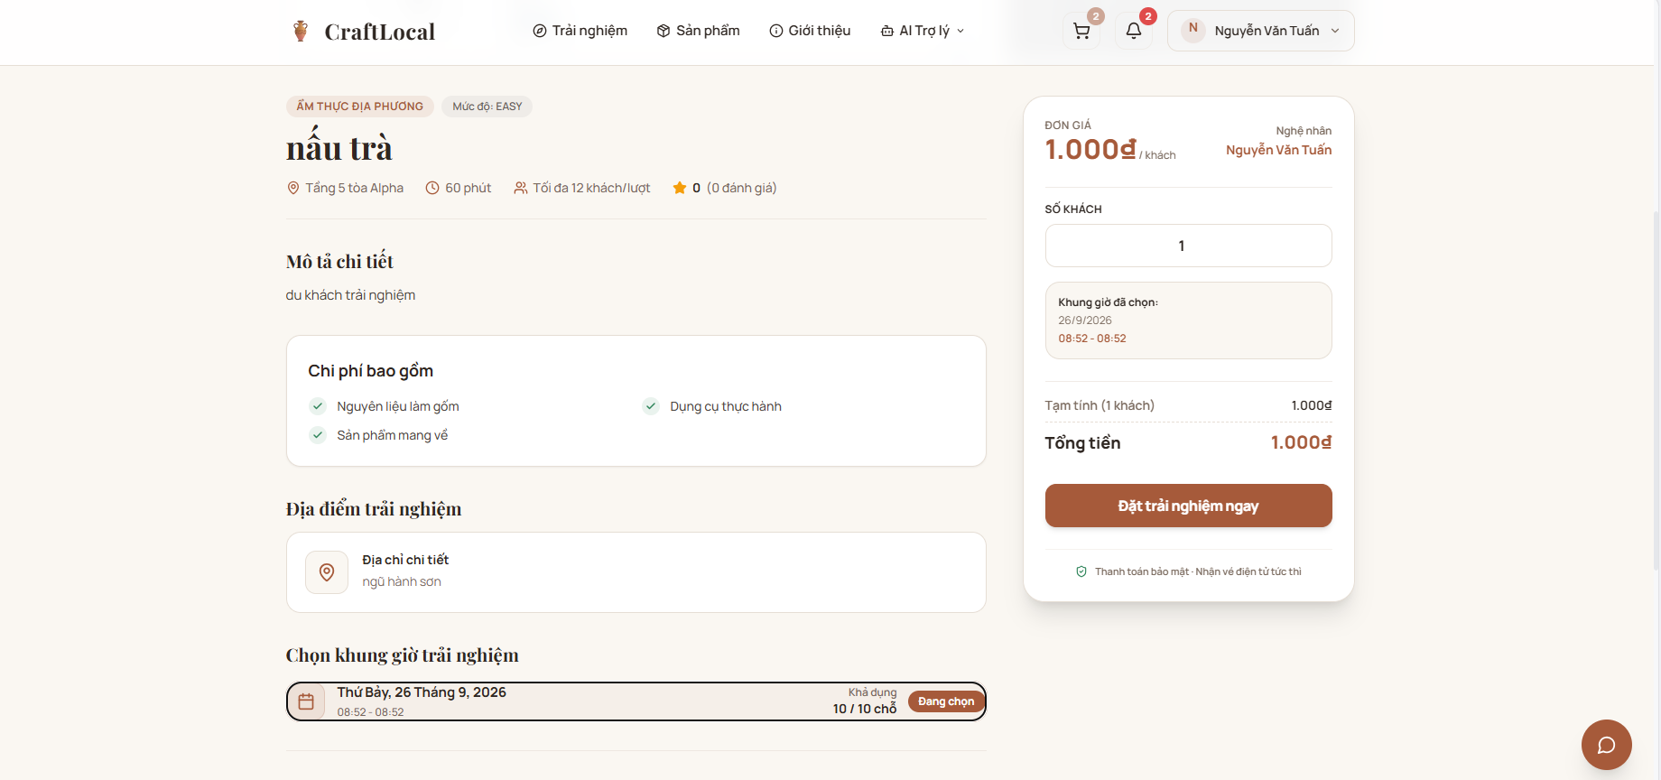
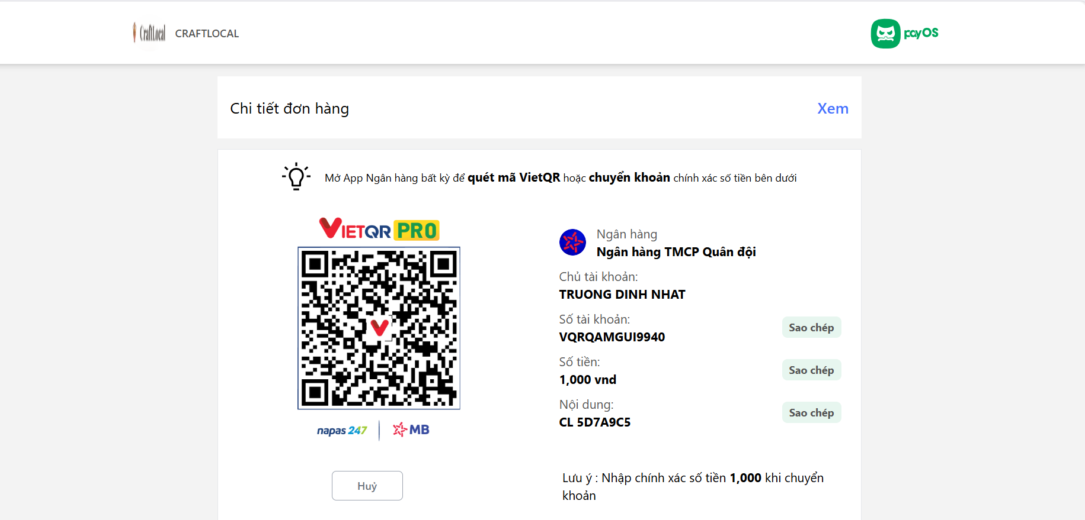
Function trigger: User views experience details, selects a time slot and guest count, clicks "Đặt trải nghiệm ngay", and completes or cancels payment on the VietQR payment gateway.
Function description:
Actors: Customer, Guest, System (PayOS / Payment Gateway)
Purpose: Allow users to view experience information, select available time slots, specify number of guests, initiate booking, and complete payment via VietQR bank transfer.
Data Processing:
- Display Details & Slot Selection:
  - Fetch and display experience metadata: Title ("nấu trà"), category tags ("ẨM THỰC ĐỊA PHƯƠNG"), difficulty ("EASY"), duration ("60 phút"), capacity ("Tối đa 12 khách/lượt"), address, included costs, artisan profile, and base price ("1.000đ/khách").
  - Render available time slots with date, time range, and real-time availability (e.g., "10 / 10 chỗ").
  - Update summary card upon selecting a time slot ("Đang chọn").
- Input Validation & Calculation:
  - Validate guest count input to ensure it is a positive integer and does not exceed available slot capacity.
  - Dynamically calculate subtotal and total cost (Total Amount = Unit Price × Guest Count).
- Booking Initiation & Redirection:
  - Upon clicking "Đặt trải nghiệm ngay", validate that required time slot and guest count fields are selected.
  - Create a pending booking order, generate transaction reference ("CL 5D7A9C5"), and redirect to the VietQR payment gateway screen.
- VietQR Payment Processing & Verification:
  - Display payment details: Bank Name ("Ngân hàng TMCP Quân đội"), Account Name ("TRUONG DINH NHAT"), Account Number ("VQRQAMGUI9940"), Transfer Amount ("1,000 vnd"), Reference Code, and dynamic VietQR code.
  - Provide copy functionality ("Sao chép") for account number, amount, and payment reference.
  - Allow expanding/collapsing order details ("Xem" / "Chi tiết đơn hàng").
  - Listen for real-time payment confirmation via PayOS Webhook; upon successful match of amount and reference code, update status to "Paid" and redirect to the confirmation page.
- Order Cancellation:
  - If user clicks "Huỷ", release reserved slots, cancel the pending order, and return to the previous screen.

3.7. Workshop Management

3.7.1. CRUD Workshop
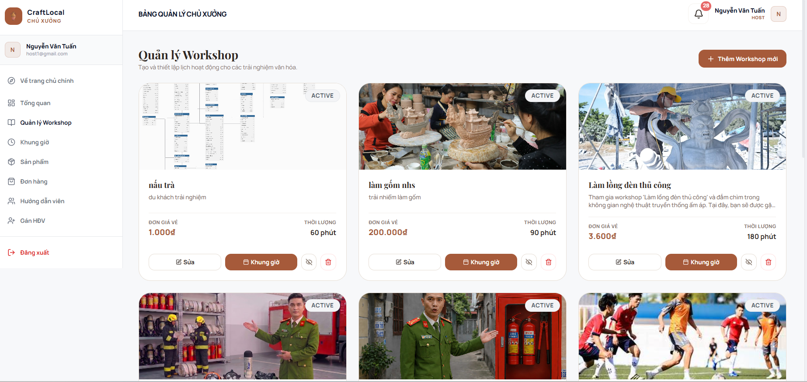
Function trigger: Host/Artisan accesses the workshop management section from the sidebar navigation or logs into the Host Dashboard.
Function description:
Actors: Host (Chủ xưởng / Nghệ nhân)
Purpose: Allow hosts to view, create, edit, manage time slots, toggle visibility, or delete cultural workshop listings.
Data Processing:
- Fetch & Display Workshop List:
  - Load and render all workshops created by the host with key details: cover image, status badge ("ACTIVE"), workshop title (e.g., "nấu trà", "làm gốm nhs", "Làm lồng đèn thủ công"), short description, ticket price ("ĐƠN GIÁ VÉ"), and duration ("THỜI LƯỢNG").
  - Display sidebar navigation options (Tổng quan, Quản lý Workshop, Khung giờ, Sản phẩm, Đơn hàng, Hướng dẫn viên, Gắn HDV).
- Create New Workshop:
  - When the host clicks "+ Thêm Workshop mới", open the creation modal/form to enter workshop details (title, pricing, duration, media, description).
- Workshop Action Controls:
  - Sửa (Edit): Redirect host to the workshop editing interface to update information.
  - Khung giờ (Slot Management): Navigate to the time slot management screen to configure available dates, times, and capacity for the specific workshop.
  - Toggle Visibility / Archive: Click eye icon to hide or unhide the workshop listing from public view.
  - Delete Workshop: Click trash icon to prompt confirmation and permanently delete the workshop record.

3.7.2. Workshop/Product Search
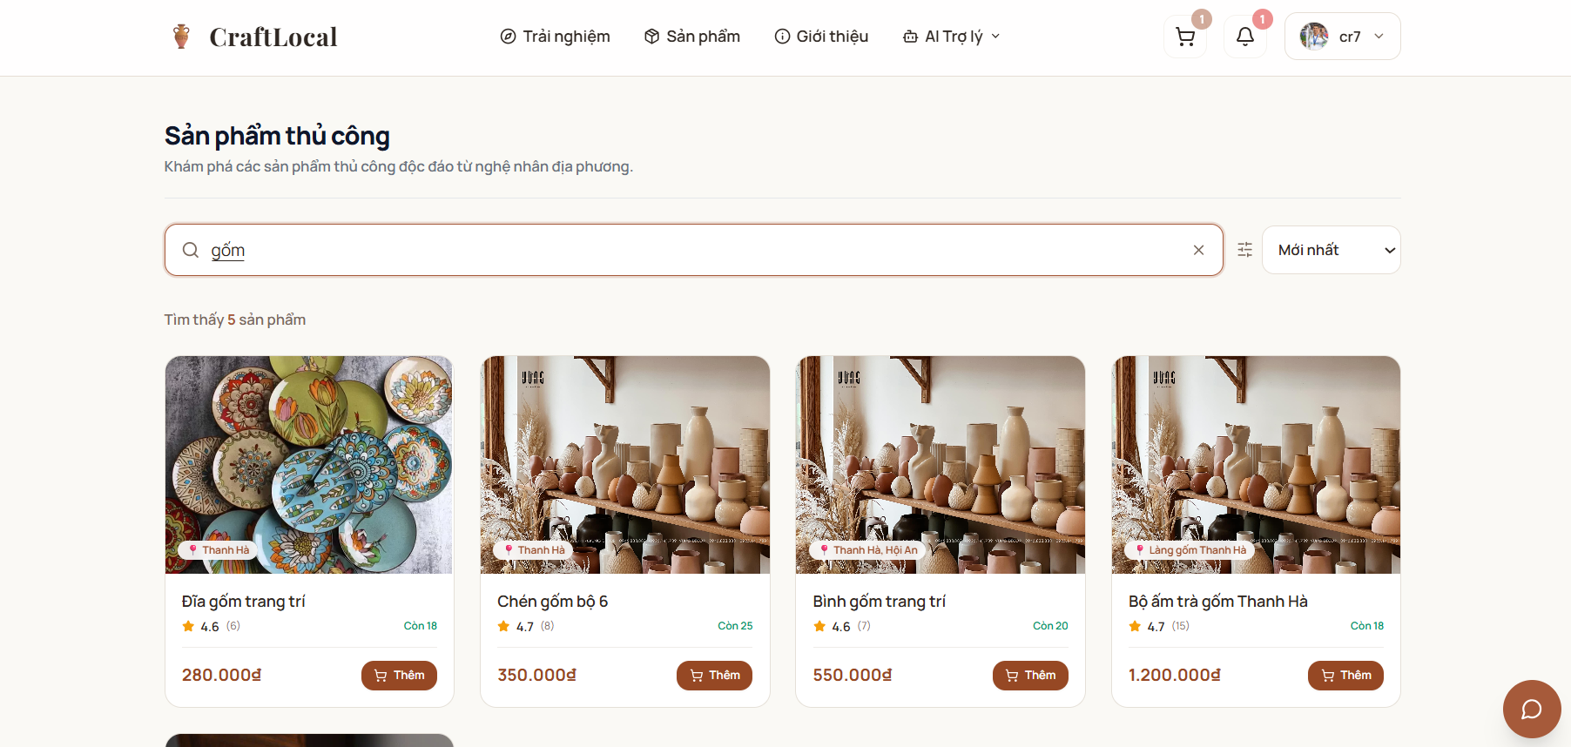
Function trigger:
The user enters a keyword in the product search field and performs a search.
Function description:
Actors: Host, Tourist, Tour Guide, Admin
Purpose: Allow users to search for local craft products using a keyword and display the matching products.
Data Processing:
- Capture the keyword entered by the user.
- Search the product records for products matching the keyword.
- Retrieve the matching product information.
- Display the search results, including product image, name, location, rating, available quantity, and price.
- Display the total number of products matching the search keyword.
- Allow the user to change the sorting option, such as Newest, to reorder the search results.
- Allow the user to select Add to add a product to the shopping cart.

3.7.3. Workshop/Product Information
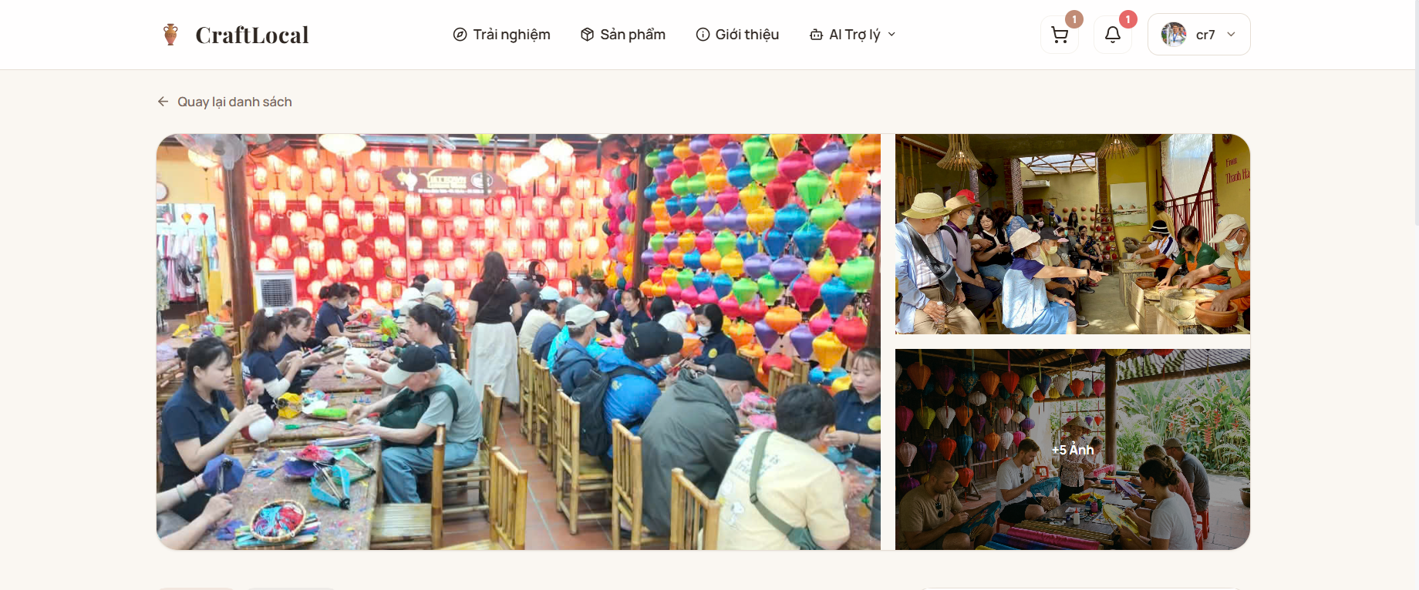

3.7.4. Create Time Slots
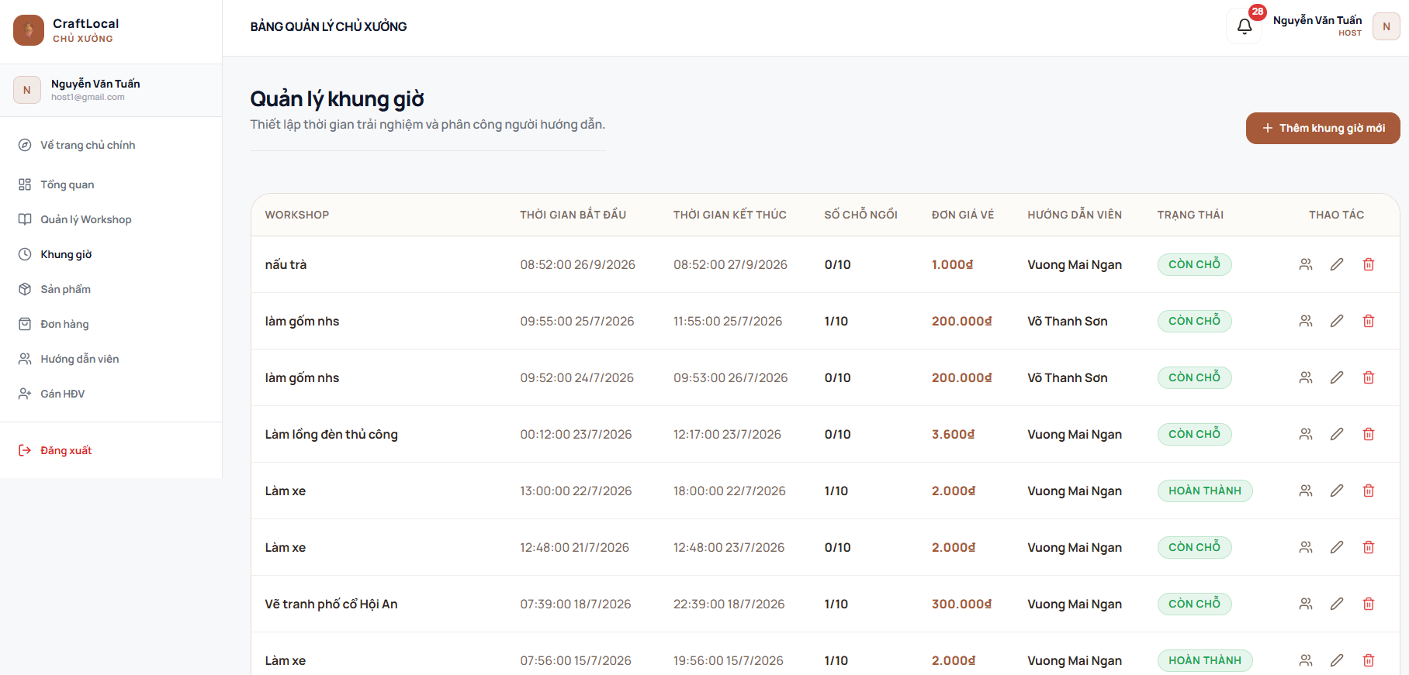
Function trigger: Host accesses the "Khung giờ" menu item from the sidebar navigation in the Host Dashboard.
Function description:
Actors: Host (Chủ xưởng / Nghệ nhân)
Purpose: Allow hosts to view, create, edit, delete time slots, assign tour guides/instructors, and monitor seat occupancy for workshops.
Data Processing:
- Fetch & Display Time Slot List:
  - Load and display table of time slots with fields: Workshop Name ("WORKSHOP"), Start Time ("THỜI GIAN BẮT ĐẦU"), End Time ("THỜI GIAN KẾT THÚC"), Seat Occupancy ("SỐ CHỖ NGỒI", e.g., "0/10", "1/10"), Ticket Price ("ĐƠN GIÁ VÉ"), Assigned Instructor ("HƯỚNG DẪN VIÊN"), Status ("TRẠNG THÁI", e.g., "CÒN CHỖ", "HOÀN THÀNH"), and Action Controls ("THAO TÁC").
- Create New Time Slot:
  - When the host clicks "+ Thêm khung giờ mới", open a form/modal to select a workshop, define start/end date-time, set seat capacity, price, and assign an instructor.
- Time Slot Management Actions:
  - Assign/Reassign Instructor (Icon người): Open a selection dialog to assign or change the instructor ("HƯỚNG DẪN VIÊN") for the specific time slot.
  - Edit Time Slot (Icon bút): Open the edit modal to update time slot details (time range, capacity, ticket price, instructor).
  - Delete Time Slot (Icon thùng rác): Prompt confirmation dialog to permanently remove the time slot record from the system.

3.8. Review Management

3.8.1. Review Workshop

3.8.2. Review Product

3.9. AI Chatbot

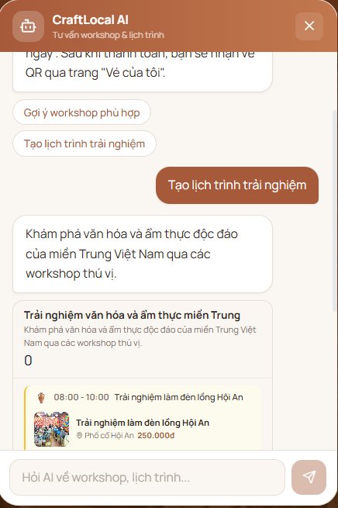

Function trigger: User clicks on the AI Assistant floating icon or selects "AI Trợ lý" from the main navigation header.
Function description:
Actors: Customer, Guest, System (CraftLocal AI)
Purpose: Provide an interactive AI-powered assistant to consult users on workshop selection, itinerary planning, ticket booking instructions, and general inquiries.
Data Processing:
- Initialize AI Chat Interface:
  - Display header title ("CraftLocal AI - Tư vấn workshop & lịch trình") and close button (X).
  - Render greeting message ("Xin chào! Mình là trợ lý AI của CraftLocal...") and quick-suggestion prompt chips: "Gợi ý workshop phù hợp", "Tìm workshop rẻ nhất", "Tạo lịch trình trải nghiệm", and "Hướng dẫn đặt vé".
- Prompt Chip Execution:
  - When the user clicks any quick-suggestion chip, automatically submit the selected chip's text as a user query to the AI engine.
- User Input & AI Processing:
  - Allow users to type custom questions into the input field ("Hỏi AI về workshop, lịch trình...").
  - Upon clicking the send button or pressing Enter, validate non-empty text, display the message in the chat timeline, and send the prompt to the AI backend service.
  - Stream/render the AI-generated response (including recommendations, links, or instructions) back to the user in real-time.
- Close Interface:
  - When the user clicks the close button (X), collapse and hide the AI assistant popup.

3.10. Notification Management

3.10.1. Send Order Notification
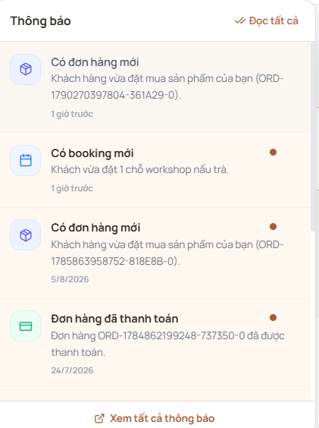

3.10.2. User’s Notification
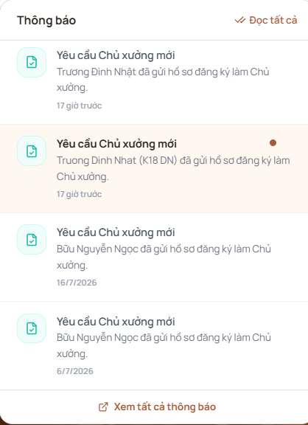

4. Non-Functional Requirements

4.1. External Interfaces

4.1.1. Database Interfaces
- The system shall use MongoDB as the database and Mongoose for database access.
- The database shall store information related to users, categories, workshops, time slots, products, bookings, tickets, orders, payments, reviews, wishlists, carts, notifications, and audit logs.
- The system shall maintain data consistency between related records such as bookings and tickets, orders and payments, and products and inventory.
- The system shall validate data before storing or updating database records.
- The system shall restrict database operations according to the authenticated user's role and permissions.
- The system shall maintain audit records for relevant system operations through the audit_logs collection.

4.1.2. API Interfaces
- The system shall provide a REST API using Node.js, TypeScript, and Express.js.
- The API shall provide authentication and authorization using JWT.
- The API shall validate request data using Zod.
- The API shall provide interfaces for:
  - Authentication and profile management.
  - Workshop and time slot discovery.
  - Workshop booking and ticket retrieval.
  - Product browsing and ordering.
  - Payment processing and payment status.
  - Reviews and ratings.
  - Host management.
  - Tour Guide schedules and check-in.
  - Admin user and Host management.
- The API shall restrict protected endpoints according to user roles.
- The API shall return appropriate responses for successful requests, validation errors, authentication errors, authorization errors, and system errors.
- The API response target shall be ≤ 2 seconds under normal load.

The documented API includes:
- /api/auth
- /api/admin
- /api/host
- /api/tour-guide
- /api/workshops
- /api/timeslots
- /api/products
- /api/bookings
- /api/orders
- /api/payments
- /api/reviews.

4.1.3. Frontend Interfaces
- The system shall provide a responsive web application for Tourist, Host, Tour Guide, and Admin users.
- The frontend shall communicate with the backend through the REST API.
- The interface shall provide functions appropriate to each user's role.
- Tourist interfaces shall support:
  - Workshop discovery and details.
  - Time slot selection and booking.
  - Payment and QR e-ticket access.
  - Product browsing, ordering, and order history.
  - Review and rating submission.
- Host interfaces shall support:
  - Workshop management.
  - Time slot and capacity management.
  - Product and order management.
  - Tour Guide management and assignment.
  - Dashboard and revenue information.
- Tour Guide interfaces shall support:
  - Assigned schedules.
  - Customer lists.
  - QR check-in.
  - Workshop start and completion.
- Admin interfaces shall support:
  - User management.
  - Host approval.
  - User blocking/unblocking.
  - Dashboard and platform statistics.
- The web application shall support desktop, tablet, and mobile screen sizes.
- The system shall provide clear validation, success, failure, and loading feedback to users.
The project scope specifies a responsive web-based platform and excludes native Android/iOS applications.

4.1.4. External Service Interfaces
- Payment Services
  - The system shall support online payment through external payment services.
  - The current backend provides payment URL creation, payment status checking, VNPay callback, and MoMo callback interfaces.
  - Payment failures shall be handled without creating an invalid completed transaction.
- Email Service
  - The system shall use Nodemailer for email-related functions.
  - Email functionality shall support system notifications such as account/password-related communication where applicable.
- Image/File Service
  - The system shall use Multer for file upload processing.
  - The system shall use Cloudinary for image storage/delivery in the deployed environment.
  - Images may be associated with workshops, products, user profiles, and reviews.
- QR Code Service
  - The system shall generate QR codes for electronic workshop tickets.
  - Tour Guides shall be able to use QR tickets to verify customer check-in.
  - Invalid or unsuccessful QR verification shall not be recorded as a valid check-in.
The implemented backend explicitly lists Multer + Cloudinary, qrcode, Nodemailer, VNPay and MoMo callback interfaces.

4.2 Quality Attributes

4.2.1. Usability
- The system shall provide clear and consistent navigation for all user roles.
- The system shall display workshop information, schedules, availability, products, prices, and relevant booking/order information clearly.
- Required input fields shall be validated before submission.
- The system shall provide clear feedback after important operations such as login, booking, payment, order submission, check-in, and profile updates.
- The system shall provide confirmation before important destructive operations where applicable.
- The system shall maintain a responsive layout across desktop, tablet, and mobile screens.
- The main Tourist workflow shall support:
  - Discover workshop → View details → Select time slot → Book → Pay → Receive QR ticket.
- The main Host workflow shall support workshop, time slot, product, order, and Tour Guide management.
- The main Tour Guide workflow shall support schedule viewing → customer list → QR check-in → workshop progress.
- The main Admin workflow shall support user/Host management and platform monitoring.

4.2.2. Reliability
- The system shall validate booking capacity before confirming workshop reservations.
- The system shall prevent inconsistent product stock during checkout and order processing.
- The system shall handle payment gateway failures and third-party service failures appropriately.
- The system shall validate QR tickets before recording customer check-in.
- The system shall prevent invalid or duplicated check-in operations.
- The system shall require authentication and role authorization for protected operations.
- The system shall validate user input before processing requests.
- The system shall provide error handling for unavailable or failed services.
- The system shall maintain system logs and audit records for relevant operations.
- The system shall follow the project's quality targets:
  - Critical module test coverage: ≥ 80%
  - Code review coverage: 100%
  - Critical defects before release: 0
These requirements address the main project risks identified in Report 2, including payment failure, booking capacity conflicts, QR verification errors, product stock inconsistency, third-party service downtime, internet problems, and security risks.

4.2.3. Performance
- The API response target shall be ≤ 2 seconds under normal load.
- Workshop and product listing operations shall support appropriate filtering and retrieval of available data.
- Booking and checkout operations shall validate capacity or product availability before completing the transaction.
- The system shall avoid unnecessary repeated requests during normal user operations.
- Images shall be stored and delivered through the configured image service to support efficient web delivery.
- The system shall support the project's planned testing and quality targets for critical modules.
The API response target and testing quality targets are explicitly defined in the Project Management Plan.

5. Requirement Appendix
5.1. Business Rules
ID | Rule | Definition
BR-001 | Authentication | Users must authenticate before accessing protected functions.
BR-002 | Role Authorization | System functions shall be restricted according to Tourist, Host, Tour Guide, and Admin roles.
BR-003 | Host Approval | A Host account must be approved by Admin before performing Host management operations.
BR-004 | Workshop Availability | Tourists can only book available workshop time slots.
BR-005 | Capacity Control | A booking must not exceed the available capacity of the selected time slot.
BR-006 | Payment | Online booking and product orders shall use the configured payment process before being treated as successfully paid.
BR-007 | E-Ticket | A valid workshop booking shall provide an electronic ticket with a QR code.
BR-008 | QR Check-in | A Tour Guide shall verify the customer's QR ticket before recording check-in.
BR-009 | Workshop Progress | Only an authorized Tour Guide assigned to a time slot can update its workshop progress.
BR-010 | Product Availability | A product order shall not exceed the available product stock.
BR-011 | Order Processing | Product orders shall be processed according to their recorded order and payment status.
BR-012 | Review | Tourists can submit reviews and ratings for completed experiences according to the system's review process.
BR-013 | User Management | Admin can manage users and block or unblock user accounts.
BR-014 | Host Management | Admin can review and approve Host registrations.
BR-015 | Payment Dependency | Payment processing depends on external payment services.
BR-016 | Delivery | Product delivery is handled by the Host or an external delivery provider; CraftWS does not provide its own delivery network.
BR-017 | Check-in Method | Workshop check-in uses QR tickets; biometric or facial-recognition check-in is outside the project scope.
BR-018 | Platform Scope | The system focuses on cultural/craft workshops and local handmade products and does not provide hotel, restaurant, transportation, or full-tour package booking.
BR-019 | Platform Type | The system is a responsive web application; native Android and iOS applications are outside the current scope.
BR-020 | Internet Dependency | Core system functions require an internet connection.

5.2. Common Requirement
ID | Requirement | Definition
CR-001 | Authentication | The system must provide registration, login, logout, password management, and profile management.
CR-002 | Authorization | The system must implement role-based access for Tourist, Host, Tour Guide, and Admin.
CR-003 | Validation | The system must validate user input before processing requests.
CR-004 | Security | The system must use secure password handling and JWT-based authentication.
CR-005 | Responsive Web | The system must provide a responsive web interface.
CR-006 | Workshop Discovery | The system must provide workshop discovery and workshop detail information.
CR-007 | Time Slots | The system must provide workshop timeslot and availability information.
CR-008 | Booking Capacity | The system must prevent booking beyond available capacity.
CR-009 | Booking | The system must support online workshop booking and booking history.
CR-010 | E-Ticket | The system must generate and provide QR e-tickets for workshop bookings.
CR-011 | Check-in | The system must support QR-based customer check-in for Tour Guides.
CR-012 | Product Order | The system must support product browsing, cart/order processing, and order history.
CR-013 | Inventory | The system must validate product availability before completing an order.
CR-014 | Payment | The system must support online payment and payment status checking.
CR-015 | Review | The system must support workshop reviews and ratings.
CR-016 | Host Management | The system must support Host workshop, time slot, product, order, and Tour Guide management.
CR-017 | Admin Management | The system must support Admin user management and Host approval.
CR-018 | Dashboard | The system must provide dashboard/statistical information for authorized users.
CR-019 | Messages | The system must provide appropriate error and success messages.
CR-020 | Audit & Notification | The system must maintain relevant notifications and audit records.
CR-021 | API Performance | The API response target must be ≤ 2 seconds under normal load.
CR-022 | Test Coverage | Critical module test coverage must be ≥ 80%.
CR-023 | Code Review | Code review coverage must be 100%.
CR-024 | Critical Defects | The number of critical defects before release must be 0.

5.3. Application Messages List
# | Message code | Message Type | Context | Content
1 | MSG01 | In line | Search result | No search results.
2 | MSG02 | In red, under the text box | Input-required fields | The * field is required.
3 | MSG03 | Toast message | Login failed | Incorrect username or password.
4 | MSG04 | Toast message | Register shuttle | Shuttle registration completed successfully.
5 | MSG05 | Toast message | Payment success | Payment completed successfully.
6 | MSG06 | Toast message | Payment fail | Payment failed. Please try again.
7 | MSG07 | Toast message | Booking success | Booking created successfully.
8 | MSG08 | Toast message | Time slot unavailable | This time slot is unavailable. Please select another time slot.
9 | MSG09 | Toast message | QR check-in success | Check-in recorded successfully.
10 | MSG10 | Toast message | QR check-in fail | QR ticket is invalid or cannot be verified.
11 | MSG11 | Toast message | Product out of stock | Product is out of stock.
12 | MSG12 | Toast message | Order success | Order created successfully.
13 | MSG13 | Toast message | Review submitted | Review submitted successfully.
14 | MSG14 | Toast message | Host approval | Hosts approved successfully.
15 | MSG15 | Toast message | Access denied | You do not have permission to perform this action.
16 | MSG16 | Toast message | Password changed | Password updated successfully.
17 | MSG17 | Toast message | Password mismatch | New passwords do not match.
18 | MSG18 | Toast message | System error | An error occurred. Please try again.

5.4. Other Requirements…
ID | Category | Requirement
OR-001 | Security | The system shall use JWT authentication, secure password handling, input validation, Helmet, CORS, and rate limiting.
OR-002 | Database | The system shall use MongoDB with Mongoose and maintain the required CraftLocal collections.
OR-003 | Data & Audit | The system shall maintain users, categories, workshops, timeslots, products, bookings, tickets, orders, payments, reviews, wishlists, carts, notifications, and audit logs.
OR-004 | File & Image | The system shall use Multer for upload processing and Cloudinary for production image storage/delivery.
OR-005 | Email | The system shall use Nodemailer for email-related system functions.
OR-006 | QR | The system shall generate QR codes for workshop tickets and support QR verification for check-in.
OR-007 | Payment | The system shall support the configured payment interfaces, including VNPay and MoMo callbacks.
OR-008 | Testing | The system shall perform reviewing, unit, integration, system, and acceptance testing according to the project quality plan.
OR-009 | Quality | Critical module test coverage shall be ≥80%, code review coverage shall be 100%, and critical defects before release shall be 0.
OR-010 | Scope | Native mobile applications, hotel/restaurant/transport booking, full tour packages, proprietary delivery, biometric/facial recognition, and advanced AI functions are outside the current project scope.

